Installation Guide

Table of Contents

Introduction 2

Overview 2

Purpose 2

Getting Started 2

Prerequisites 2

Installation 3

Installation on Windows 3

Installation on Linux 26

Download codebase 34

Backend Setup 34

Frontend Setup 39

# Introduction

## Overview

License Manager is a comprehensive software solution designed to streamline and automate the process of managing software licenses for organizations. This project aims to simplify license tracking, reduce compliance risks, and optimize software asset management.

## Purpose

The purpose of the License Manager application is to provide organizations with a centralized and automated solution for managing software licenses. By using this application, organizations can ensure compliance with licensing agreements, minimize the risk of non-compliance, and optimize their software asset management. The application aims to streamline license tracking, automate notifications for expiring licenses, and export license CSV, role-based authorization to keep it secure, and statistical representation of license data, all of which contribute to efficient and effective license management.

# Getting Started

## Prerequisites

To install and use the License Manager, please ensure the following prerequisites are met:

* **Operating System**: Windows 10 or later
* **Database**: MySQL version 8.0 or later
* **Runtime Environment**: Node.js version 20.11.1 or later, with npm version 10.2.4 or later
* **Web Server**: One of the following: Nginx, Apache, or IIS

## Installation

### Installation on Windows

#### 

#### Installation of web server

* IIS web server: To install IIS on windows 10, follow the steps below.
* Step 1: Search in start menu “Turn windows features on or off”

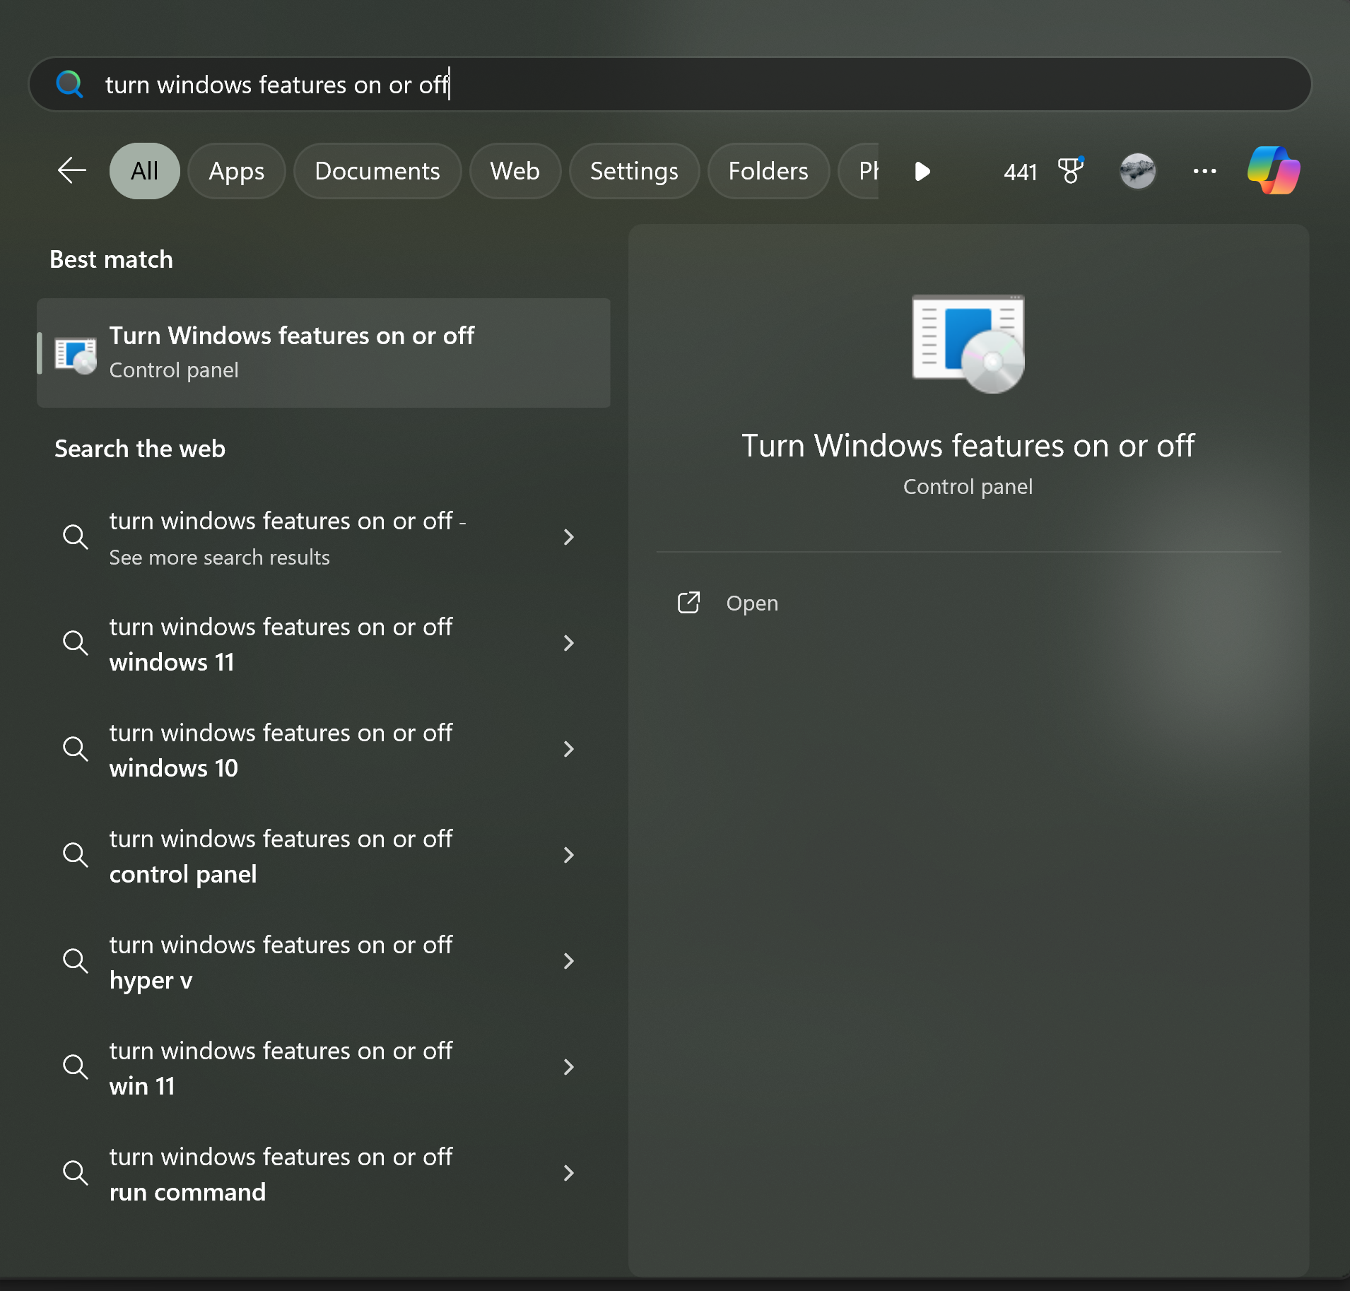

* Step 2: Find in the menu “Internet Information Services” and select the highlighted features.

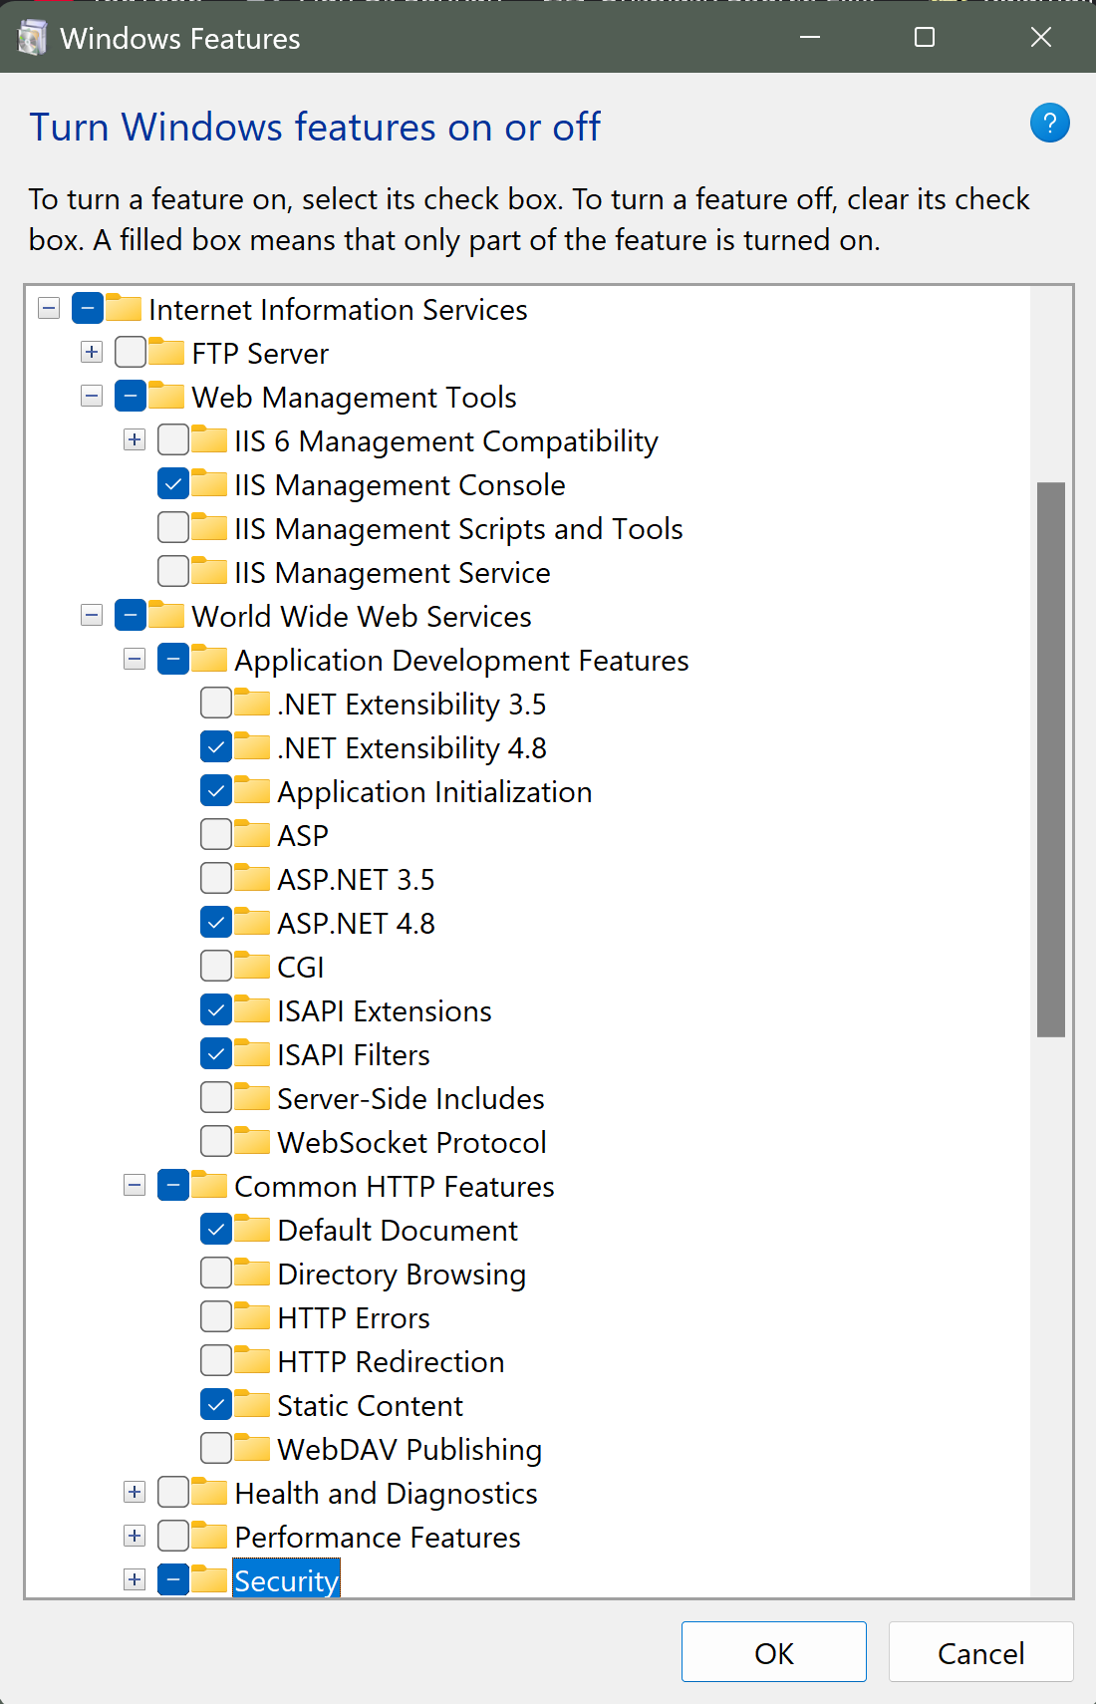

* Step 3: Press “OK”, you will se a modal saying “Applying Changes”

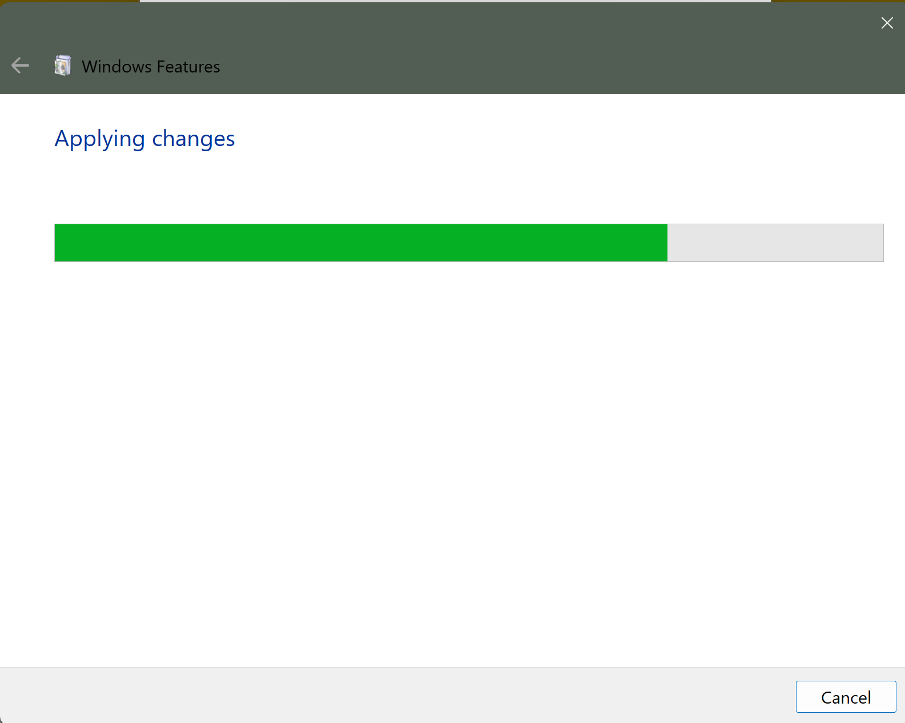

* Step 4: After it’s completion, you will be prompted to reboot to finalize the changes.

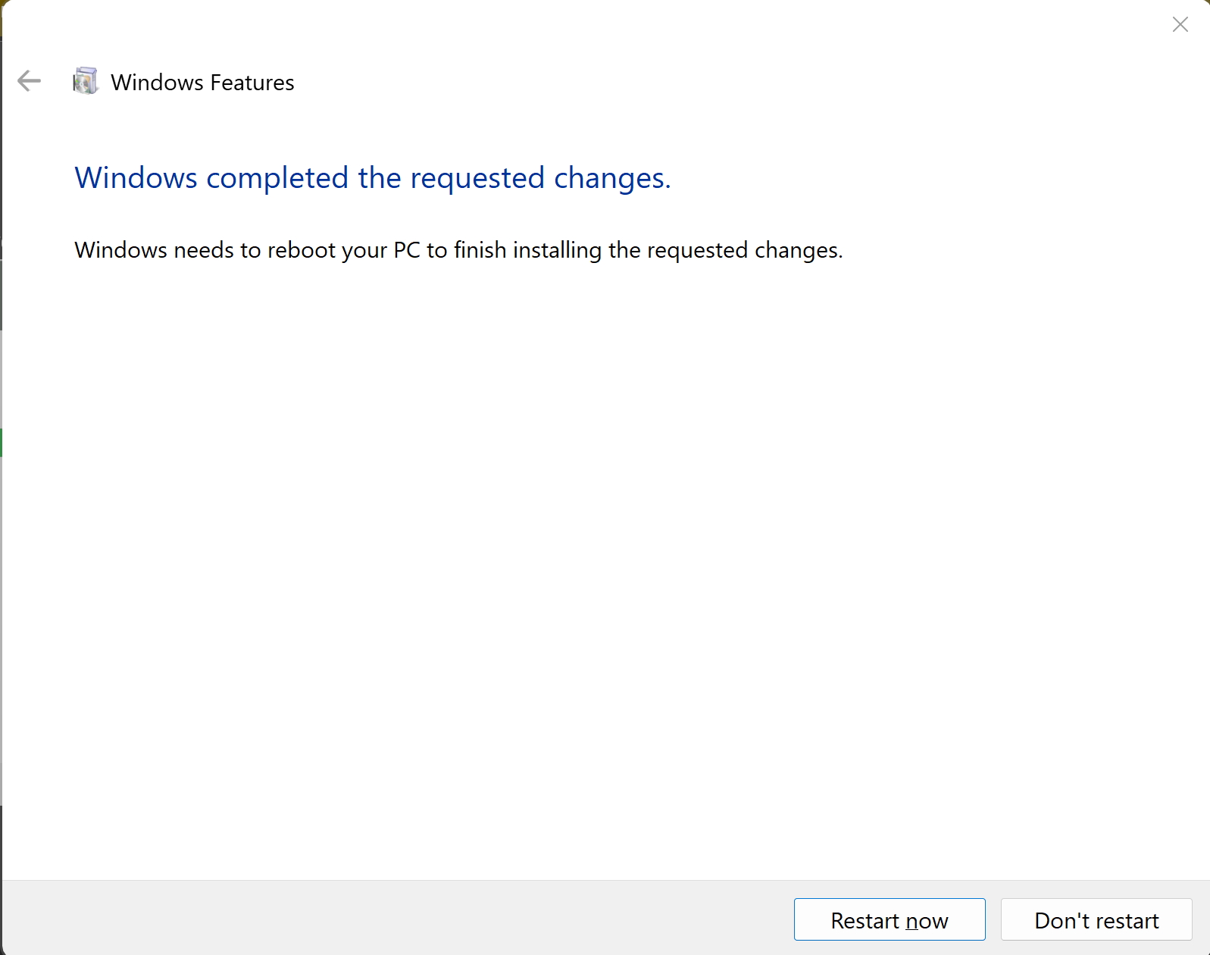

* Step 5: After rebooting, you can open IIS by searching in the start menu. By default, there is default web site in IIS.

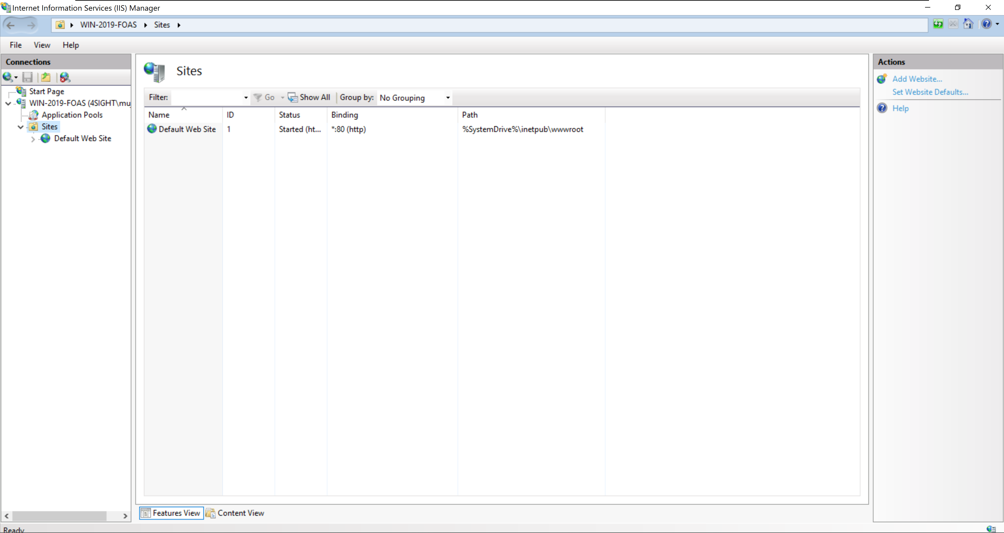

* Step 6: You can confirm the installation by opening your browser and writing in the address bar “localhost”. If you see the following screen, that means your web server IIS is setup successfully.

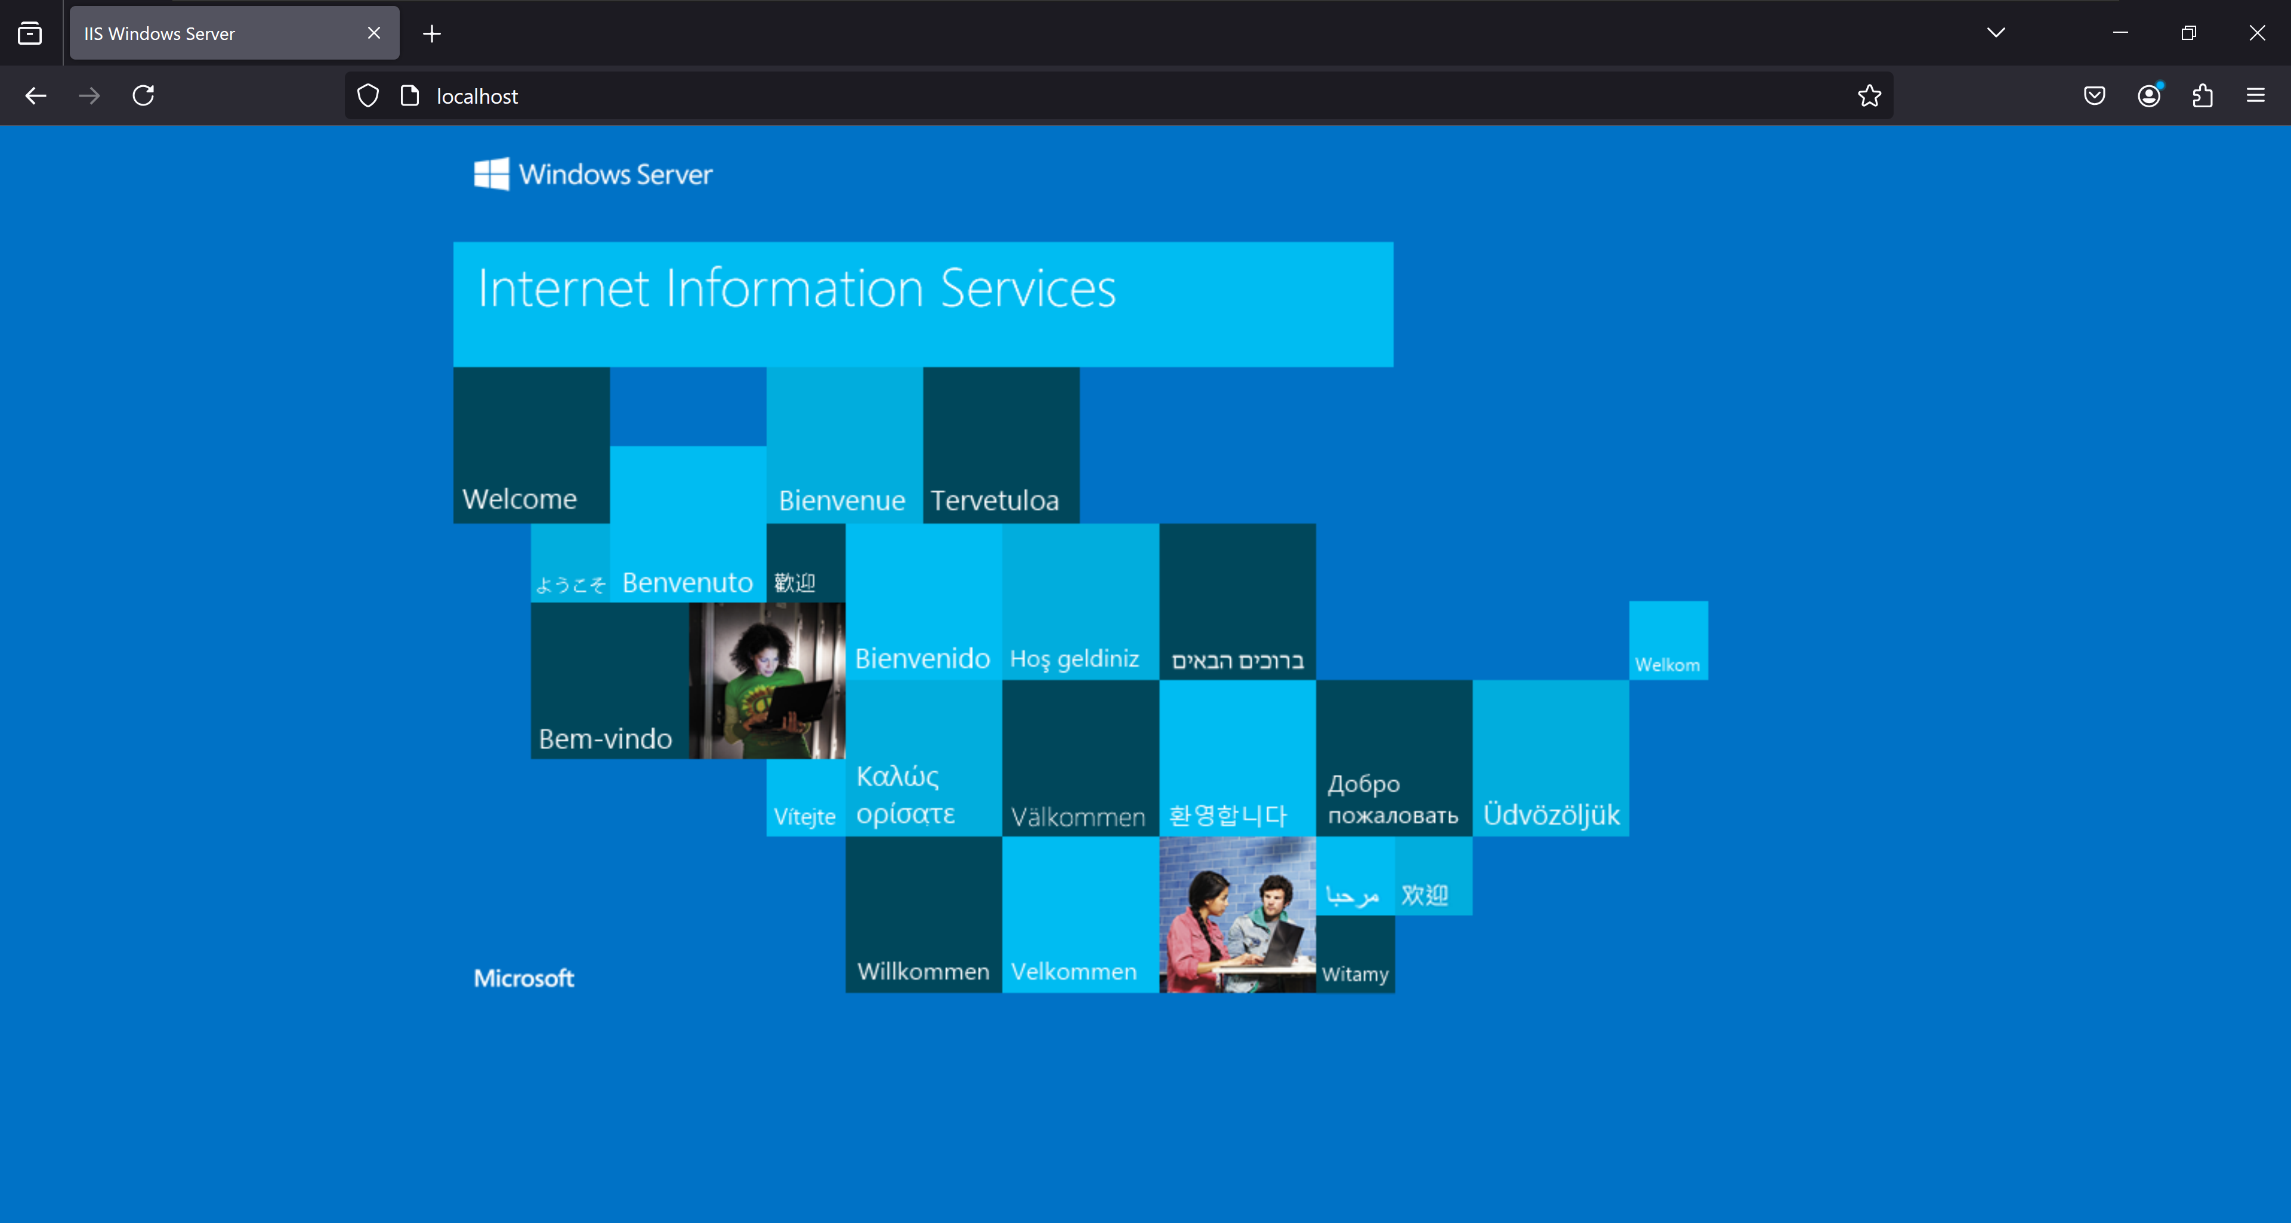

#### Installation of MySQL and creating empty database

* Step 1: The simplest and recommended method is to download MySQL Installer for Windows from <https://dev.mysql.com/downloads/installer/> and execute it. Note that version 8.0 or later is recommended for the license manager.

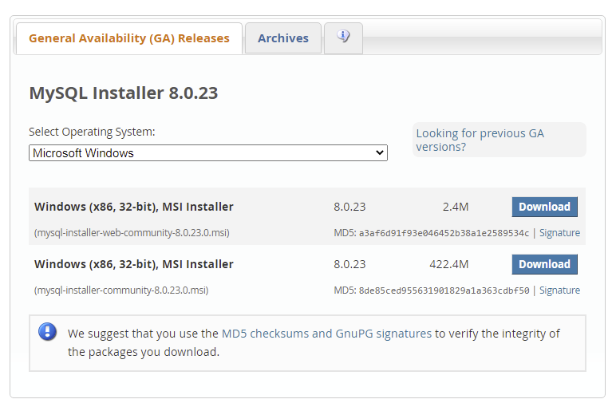

Note: On the next page, you’ll be prompted to log in or create a MySQL account. You can choose “No thanks, just start my download.”

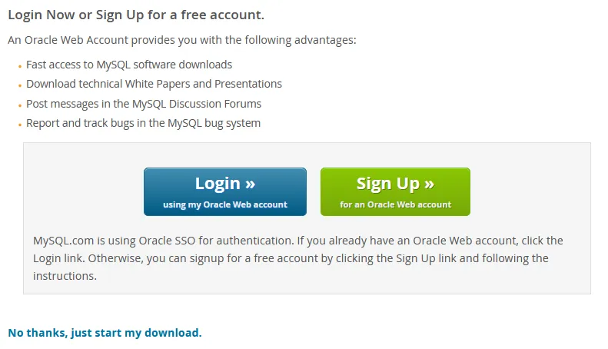

* Step 2: Locate the installer file you just downloaded (e.g., mysql-installer-web-community-x.x.xx.x.msi) and double-click it to run the installer.

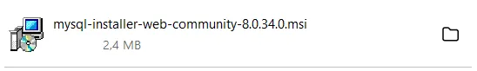

* Step 3: In the installer window, choose “Custom” under “Setup Type.” This option will let us choose the installation content MySQL Server, MySQL Workbench and other components, such as documentation and examples. Then click “Next.”

*Note: *You can also choose “full” for ease, but will need to configure MySQL router as well.*

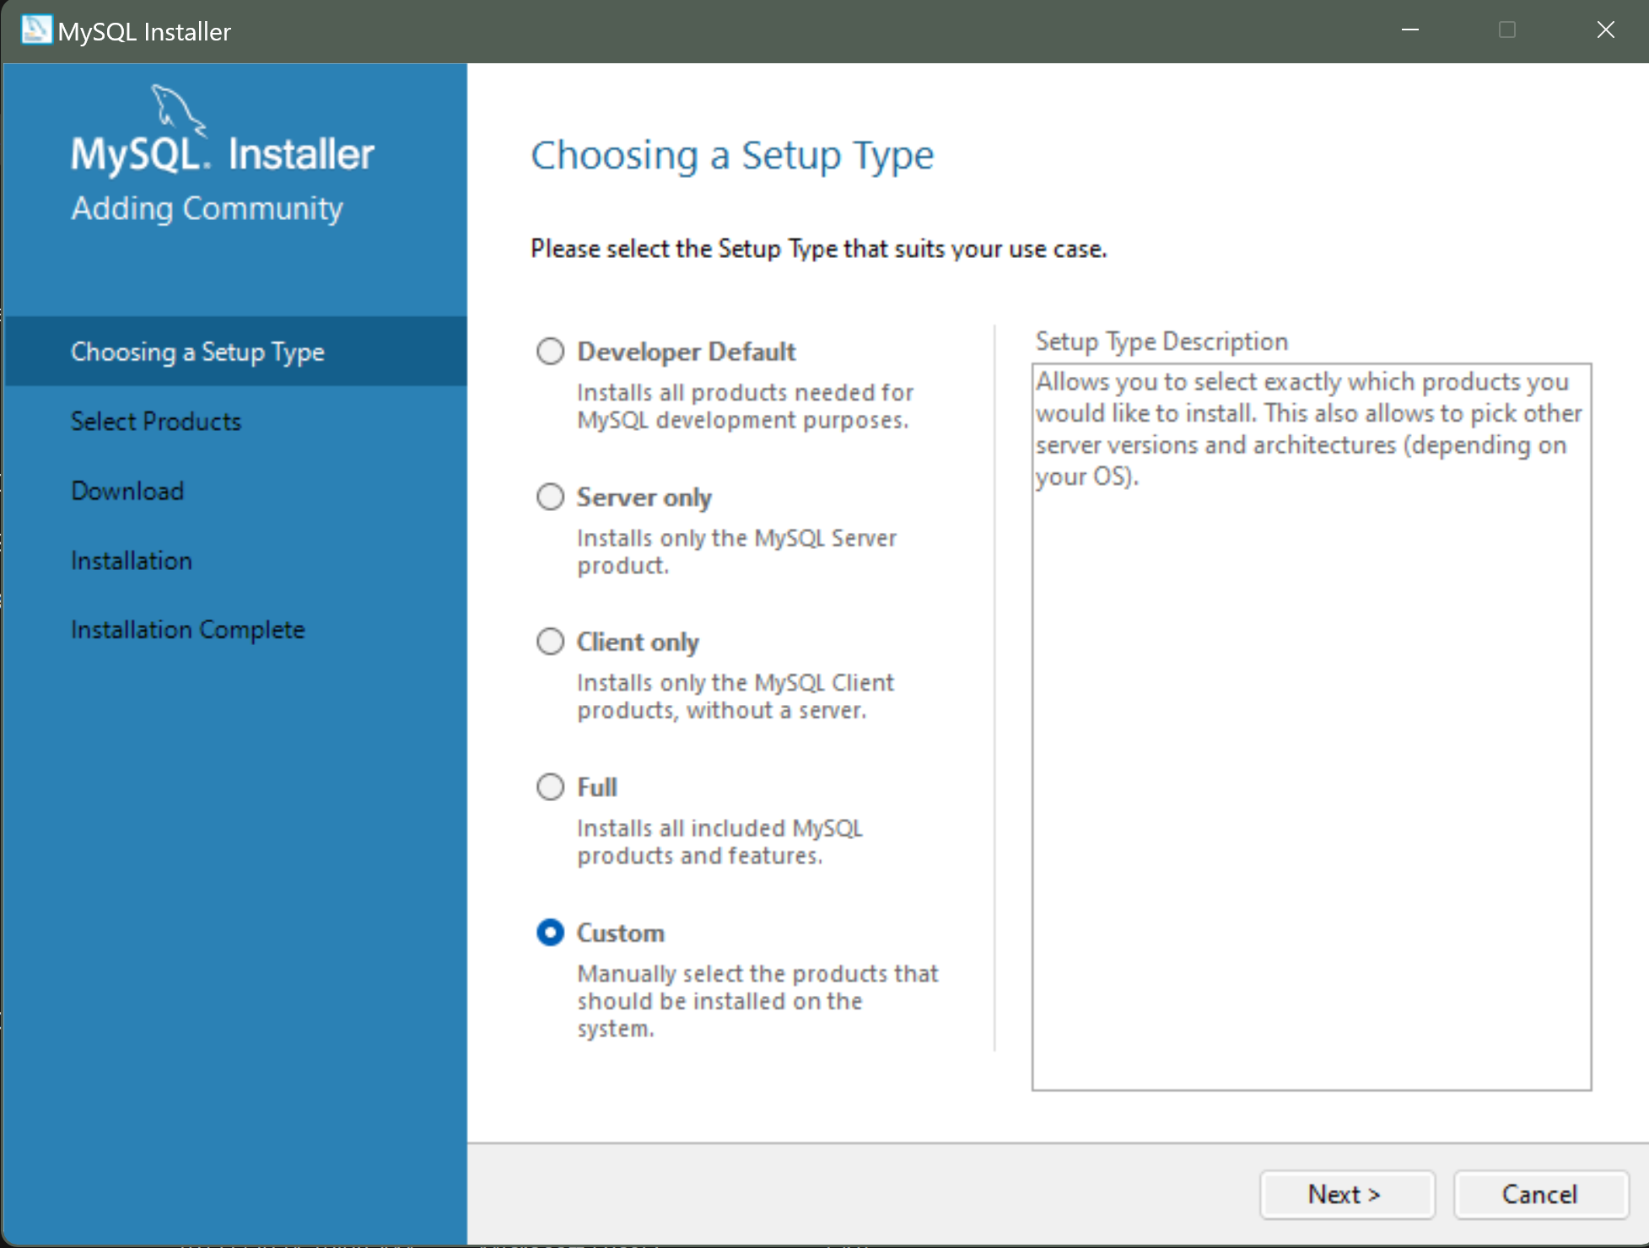

Choose the products you want to install as shown below and then click “Next”

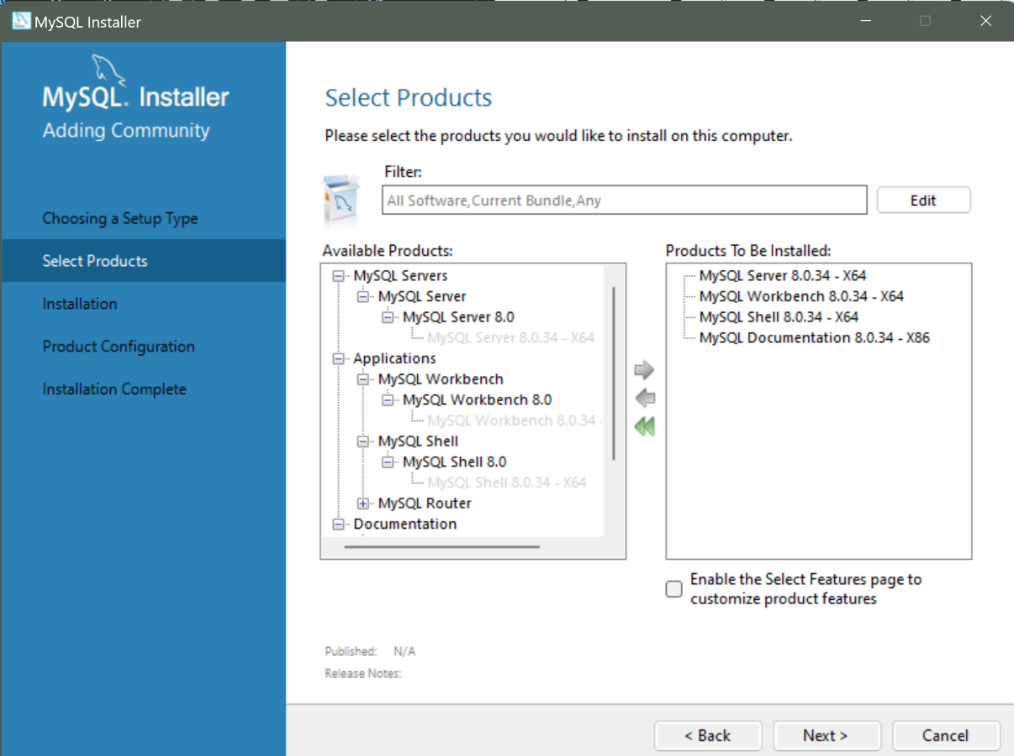

* Step 4: In the next window, just click “Execute.”

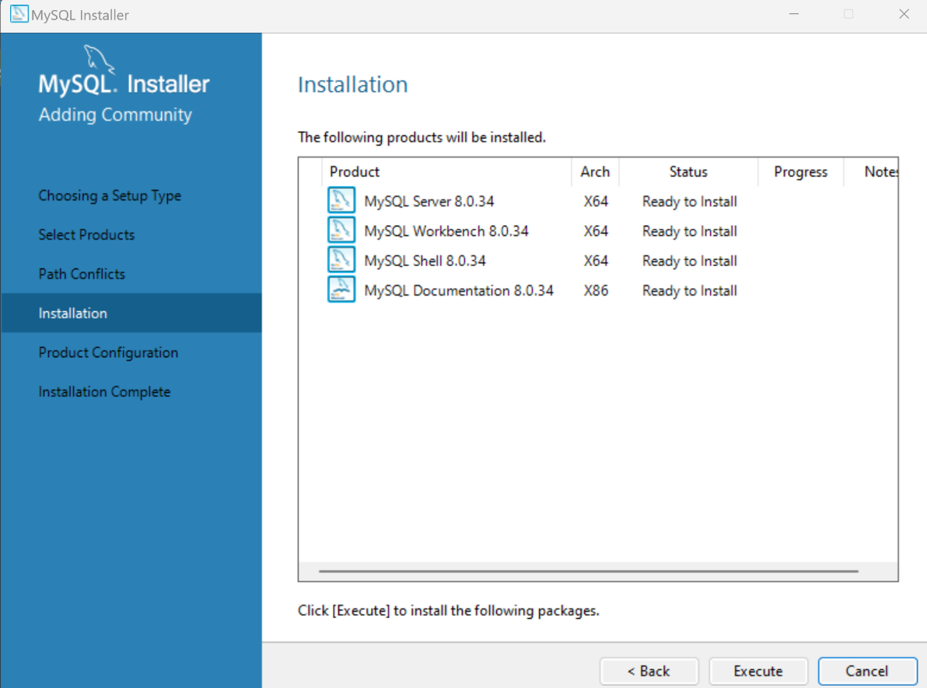

* Step 5: After all products have been downloaded sucessfully, as indicated by the green checkmark, click “Next.”

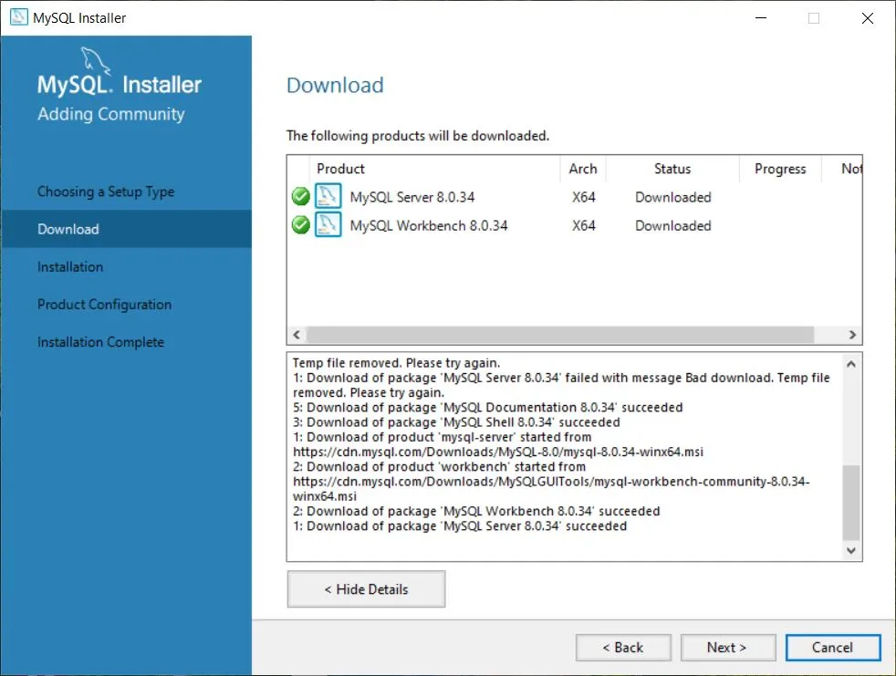

* Step 7: After all products have been installed successfully, click “Next” to start the configuration.

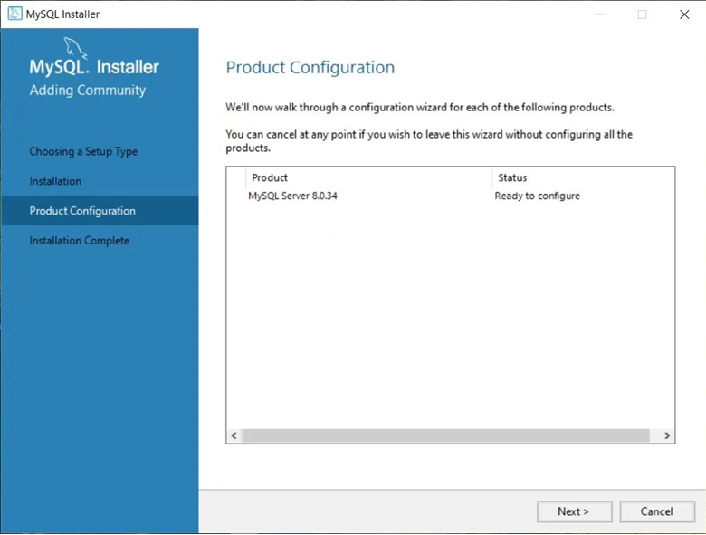

* Step 8: Under “Type and Networking” choose “Development Computer” as Config Type and leave everything else as is. Then click “Next.”

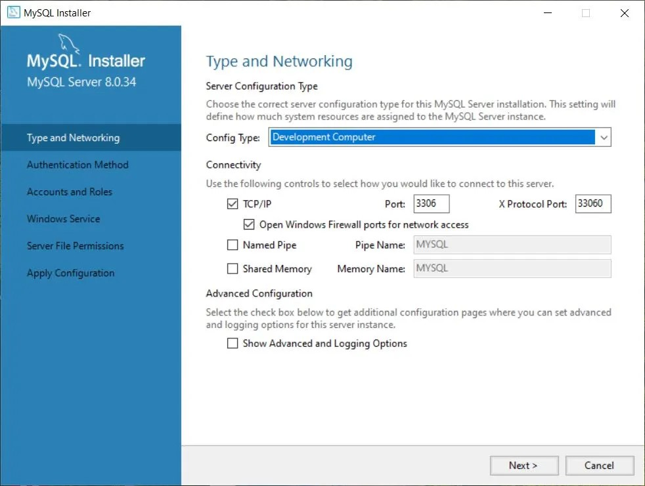

* Step 9: Next, you will be asked to choose an authentication method. For increased compatibility, choose “Use Legacy Authentication Method” and click “Next.” Choosing “Use Strong Password Encryption” will cause failure in Authentication through external applications. Therefore, **do not** select “Use Strong Password Encryption”

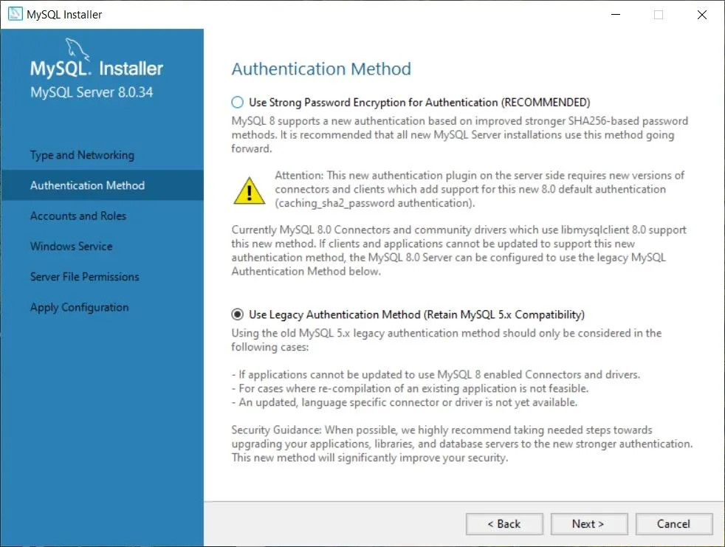

* Step 10: In the “Account and Roles” window, choose a new password for your root account. Be sure to choose a strong [**password**](https://1password.com/password-generator/) and enter the password under MySQL Root Password and Repeat Password then click “Next.”

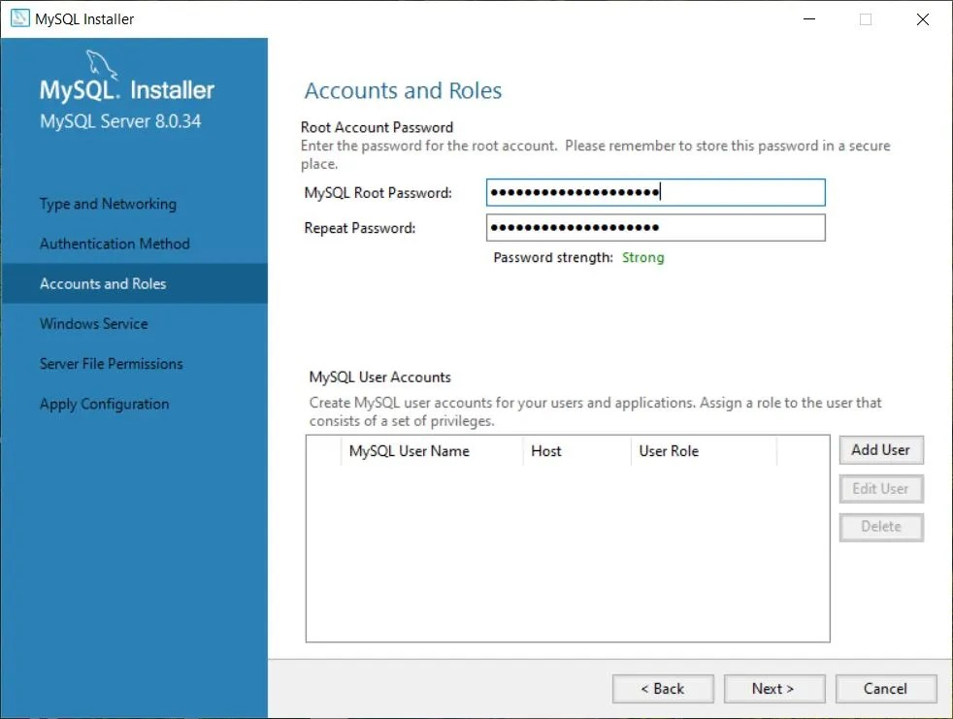

* Step 11: In the next window, leave everything as is and click “Next.”

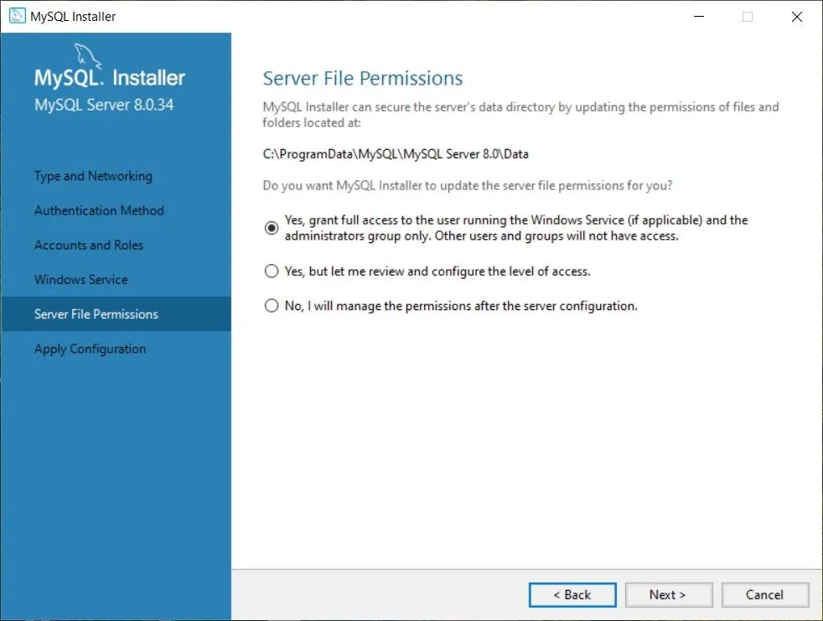

* Step 12: Next, grant full access to let the Installer update server file permissions and click “Next.” Click “Execute” to apply the configuration changes.

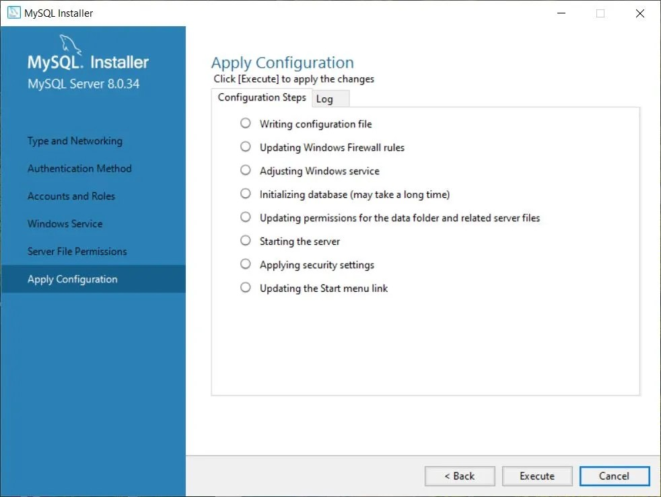

* Step 13: Once the configuration is done (green checkmarks), click “Finish.”

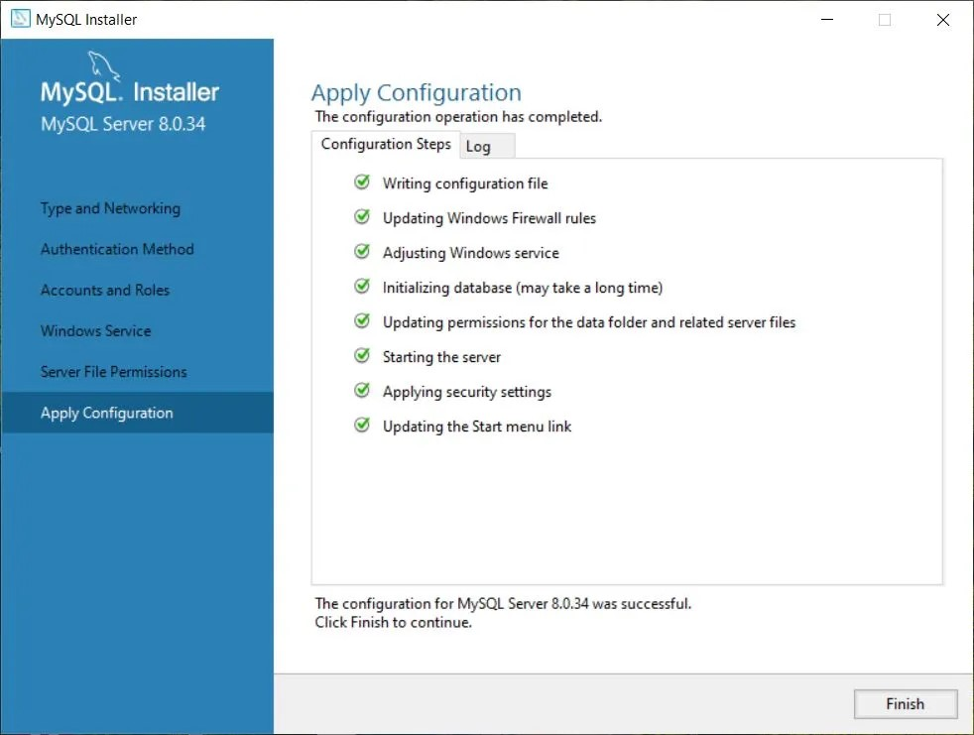

* Step 14: That’s the installation and setup done. You just downloaded and installed MySQL Server and MySQL Workbench. Click “Finish” and MySQL Workbench will launch.

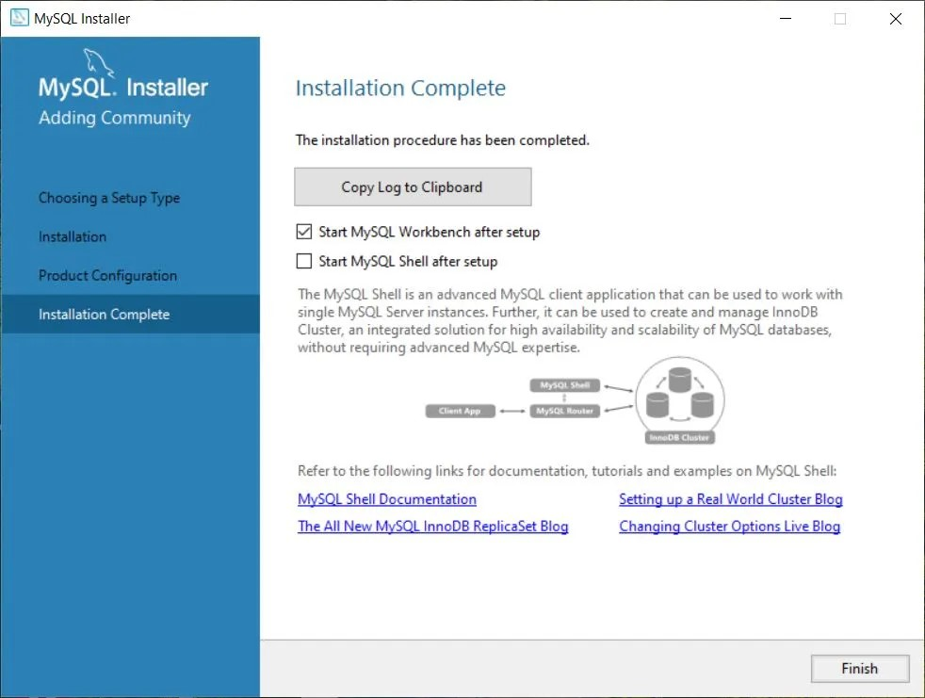

* Step 15: At the end of the installation process, MySQL Workbench should launch automatically. If it doesn’t, start the program manually. You are greeted by the graphical user interface (GUI) tool for MySQL, the MySQL Workbench. In the bottom half of the window under “MySQL Connections” you should see one tile for your local instance connection, Local instance MySQL80. Go ahead and double-click it.

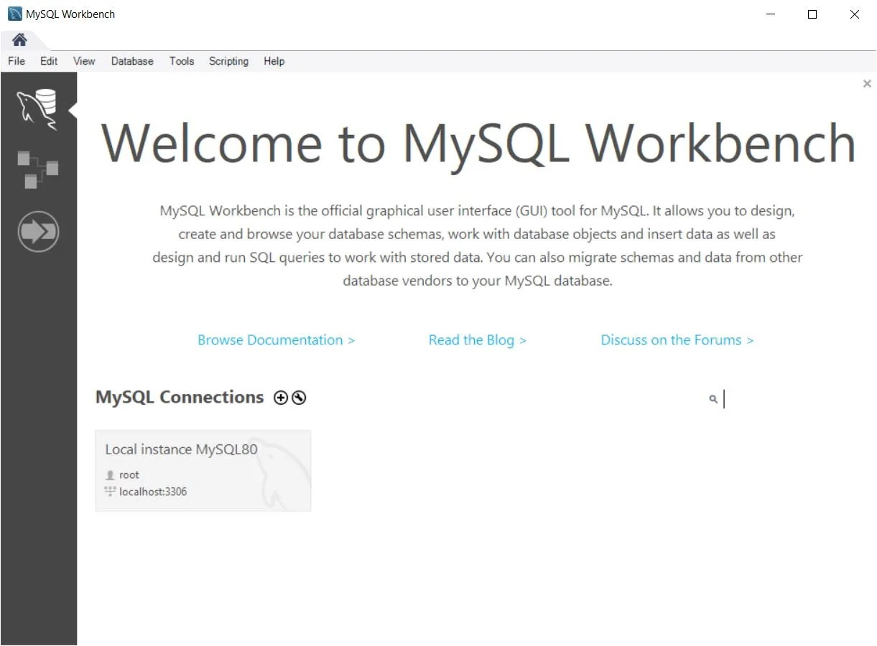

* Step 16: In the new window, enter the password you chose earlier and click “OK.”

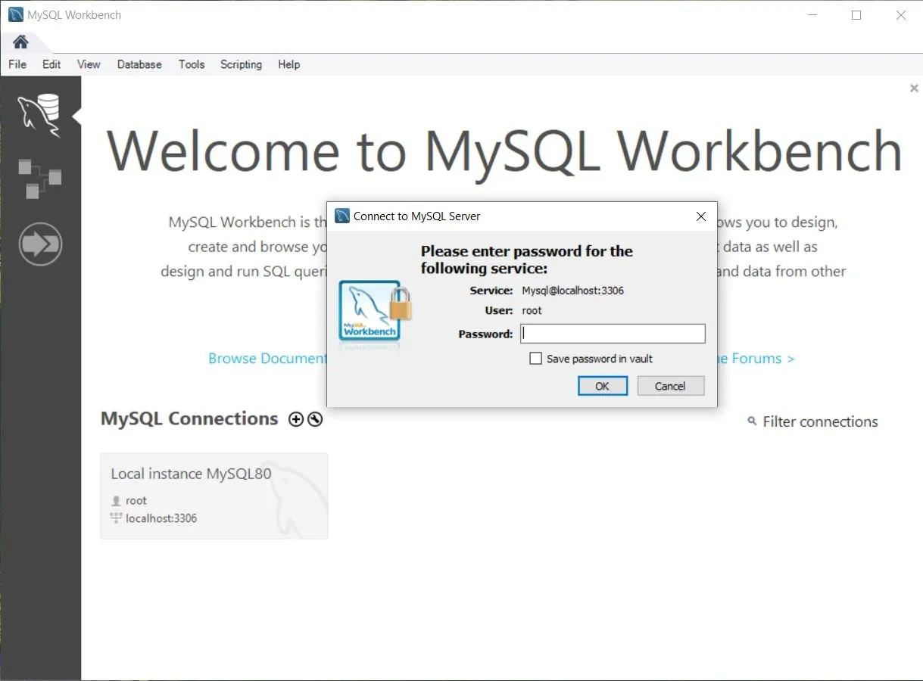

* Step 17: We’re in. You are now connected to your MySQL Server and can start using the MySQL Workbench. The Navigator is typically located on the left-hand side of the MySQL Workbench GUI. It serves as a central hub for database management and navigation. It houses some administrative features and a handy tree-like structure of all your databases under the tab “Schemas.”

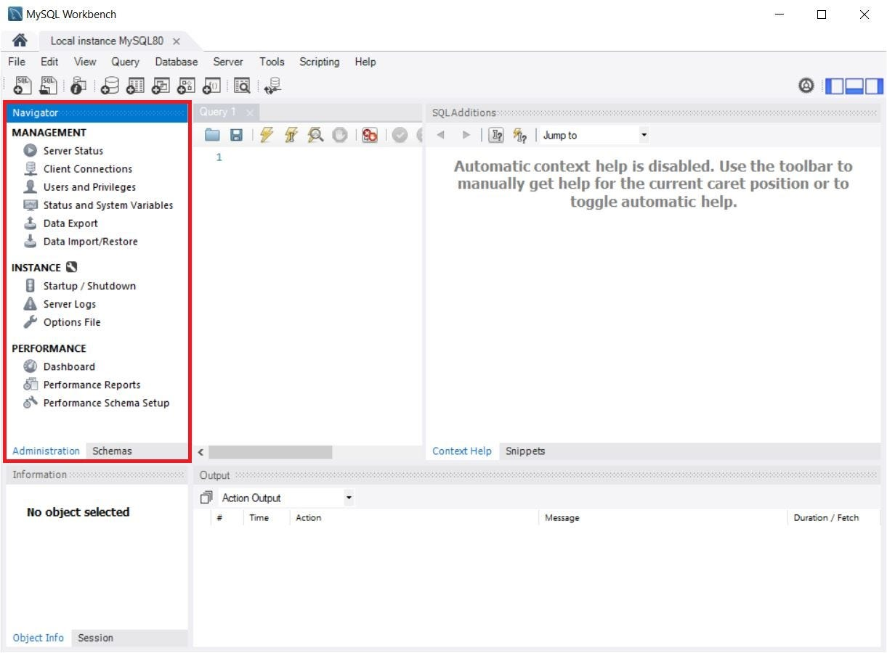

* Step 18: To enable remote connection from our application we need to create a new user with the host set to “%”.

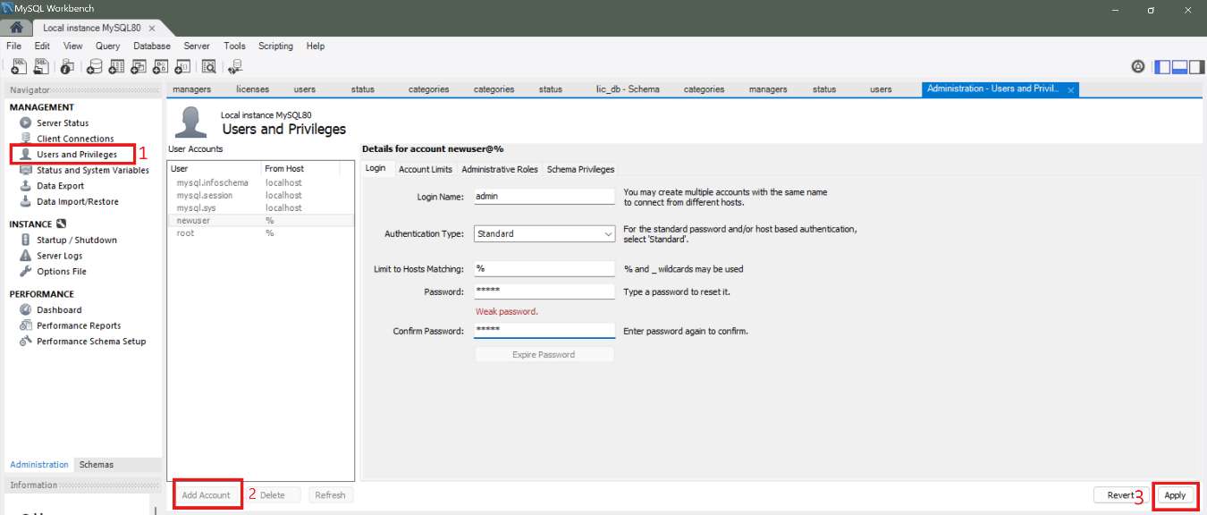

Further we need to set the user roles to ensure no permissions error occurs.

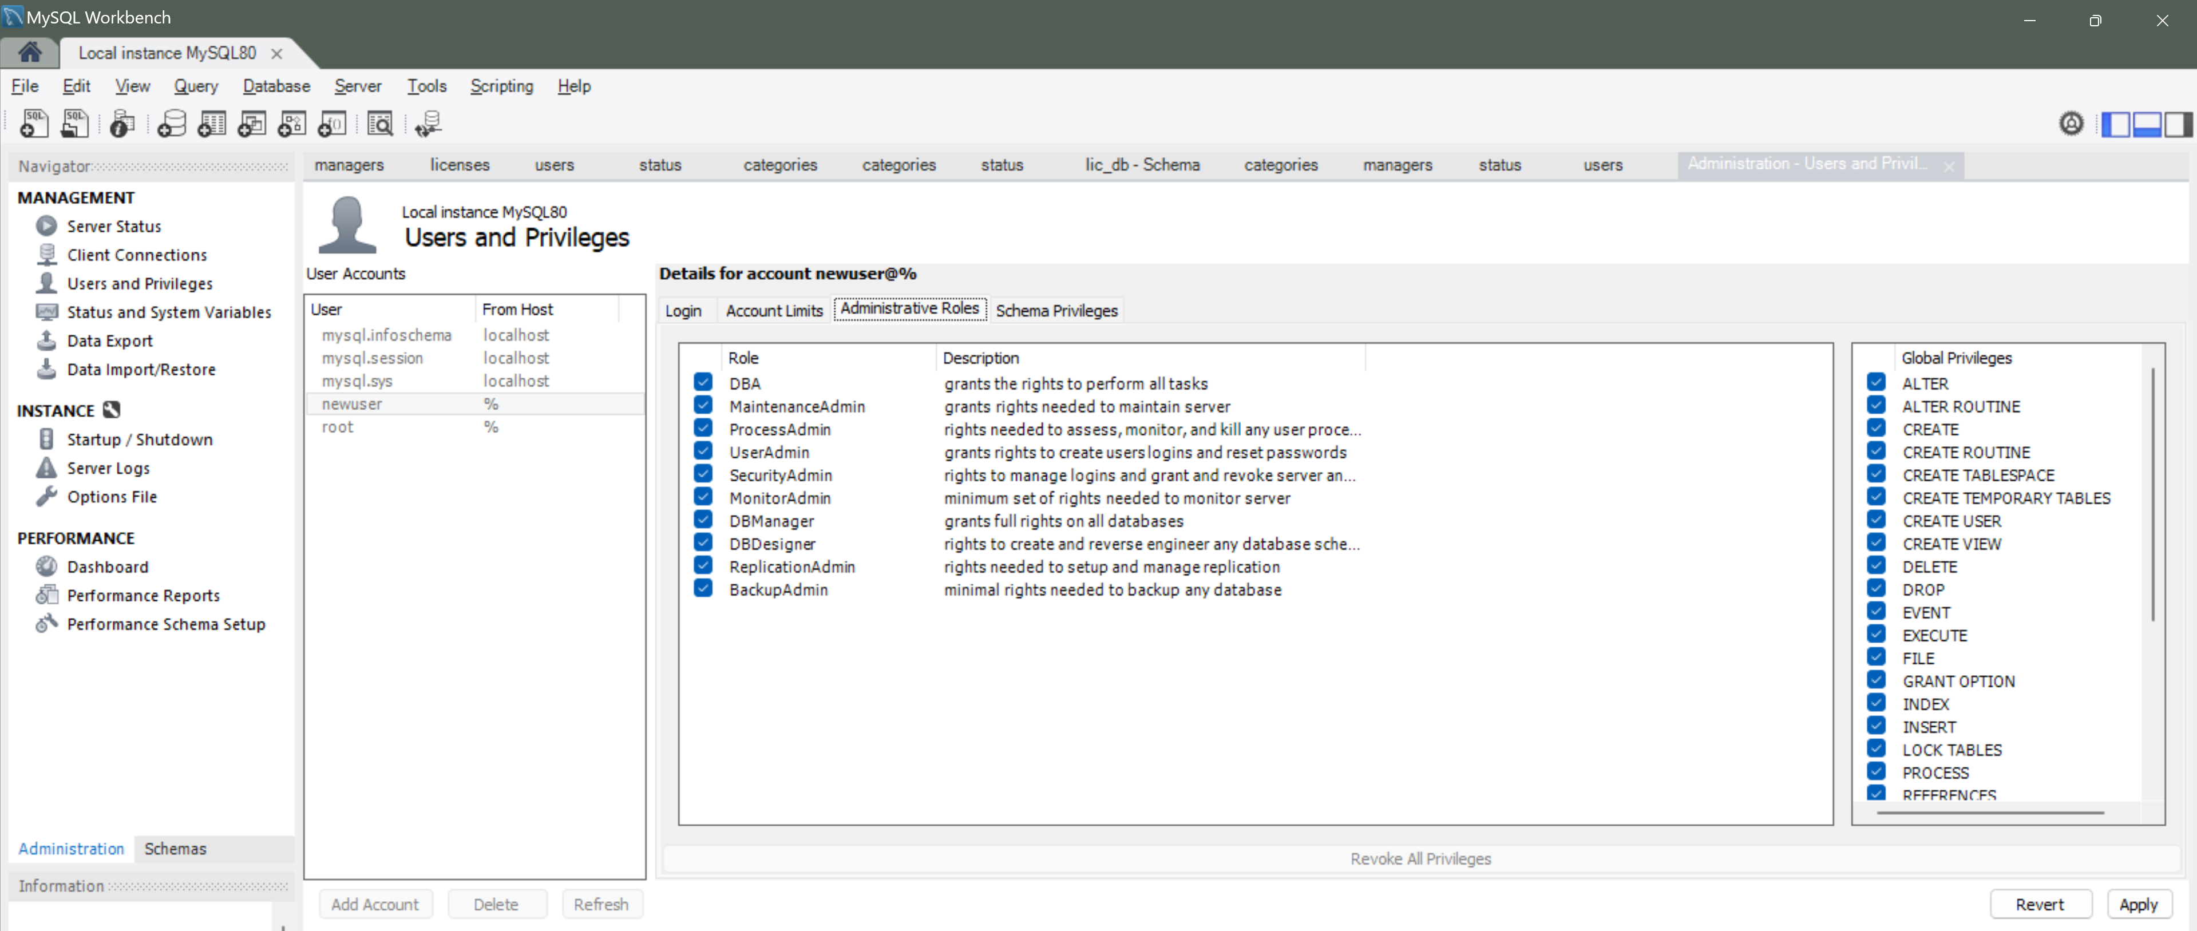

* Step 19: Navigate to the “Schemas” tab to see all your databases. To create a new database, click on the create new schema option in the top panel or right click in the empty space of the Schemas tab. Remember the database name, as it will be needed when configuring the application.

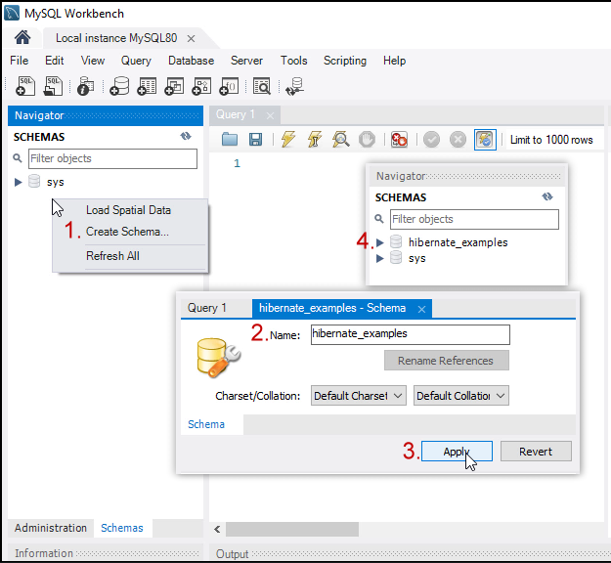

With this the installation of MySQL with its tools are installed and configured. Additionally, we have also initialized a database which we will need later.

#### Installation of node.js

* Step 1: **Download the NodeJS.** Downloading the Node.js ‘.msi’ installer the first step to install Node.js on Windows is to download the installer. Visit the official Node.js website i.e) [https://nodejs.org/en/download/](https://nodejs.org/en/download)

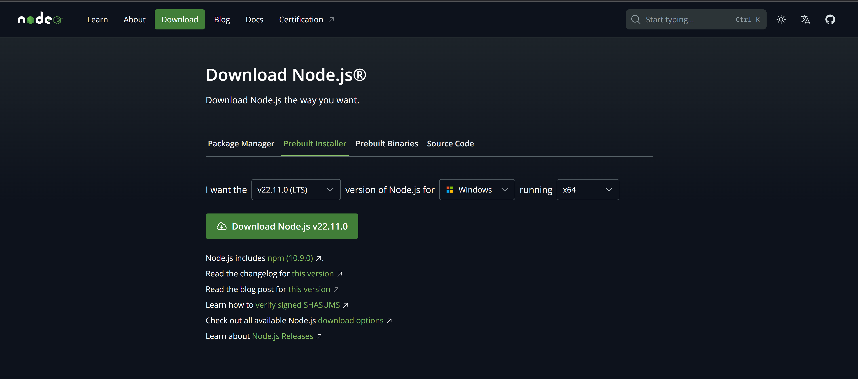

* Step 2: **Running the Node.js Installer.** Now you need to install the node.js installer on your PC. You need to follow the following steps for the Node.js to be installed: Double-click on the .msi installer

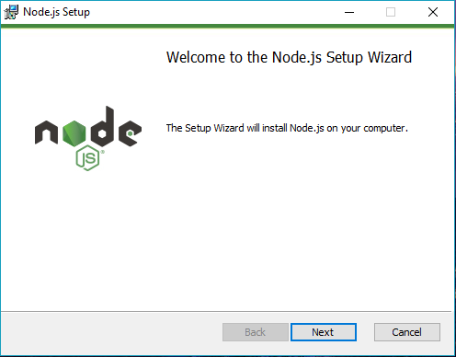

* Step 3: After clicking “Next”, the End-User License Agreement (EULA) will open. Check “I accept the terms in the License Agreement” and Select “Next”

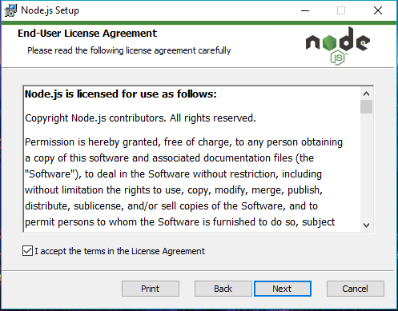

* Step 4: Destination Folder Set the Destination Folder where you want to install Node.js & Select “Next”. In most cases, the destination is kept default.

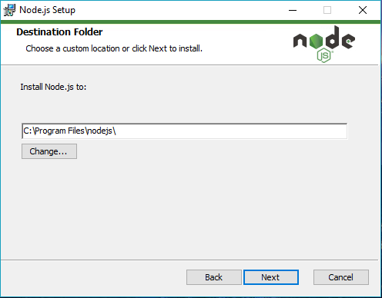

* Step 5: Select “Next”

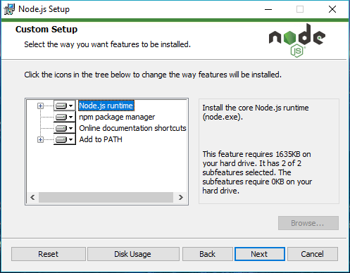

* Step 6: There is no need to install chocolatey and all necessary tools as that makes the setup use high amounts of resource. Simply Click “Next”.

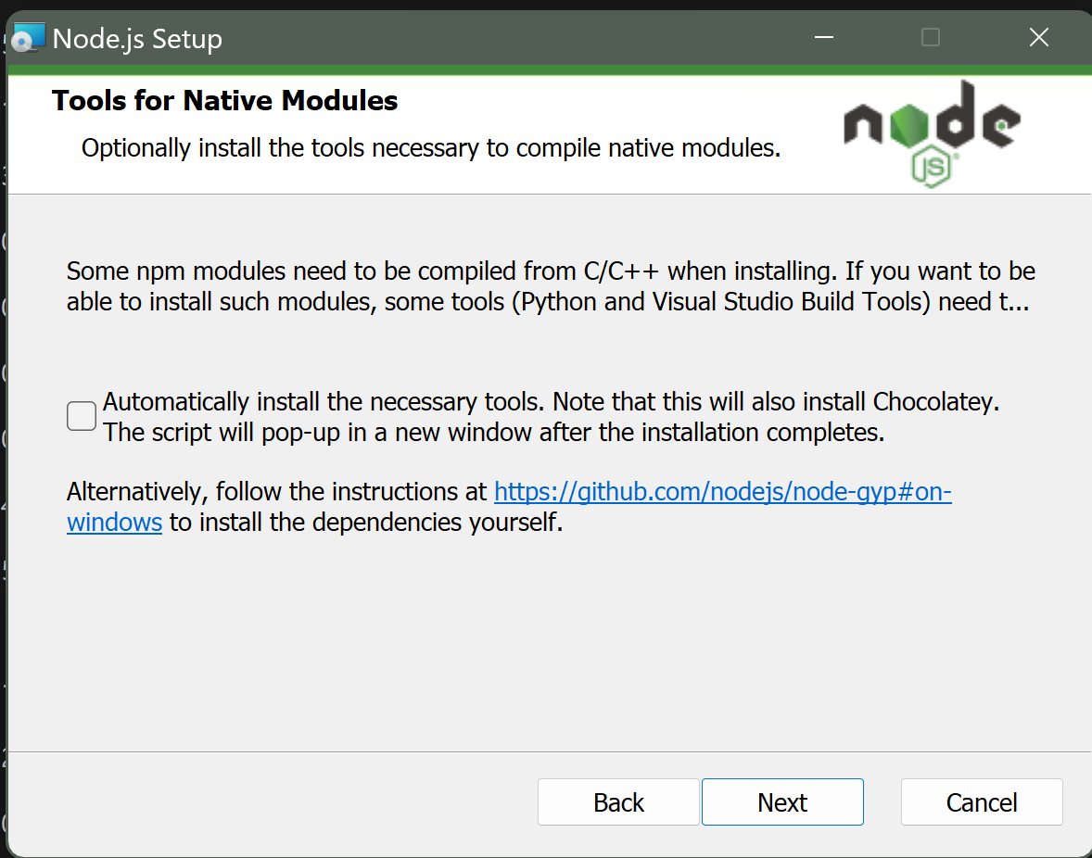

* Step 7: Ready to Install Node.js.Select “Install”

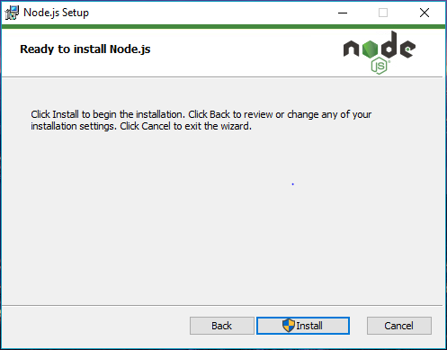

* Step 8: Do not close or cancel the installer until the installation is complete. Complete the Node.js Setup Wizard. Click “Finish”

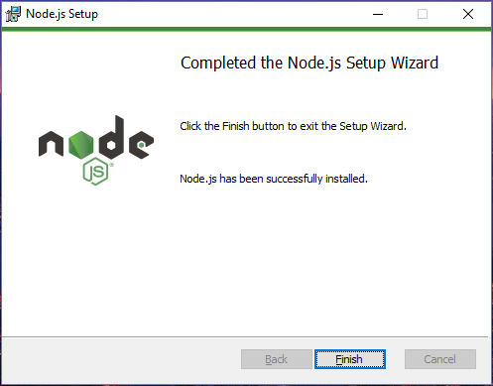

* Step 9: Verify that Node.js was properly installed or not. To check that node.js was completely installed on your system or not, you can run the following command in your command prompt or Windows PowerShell and test it.

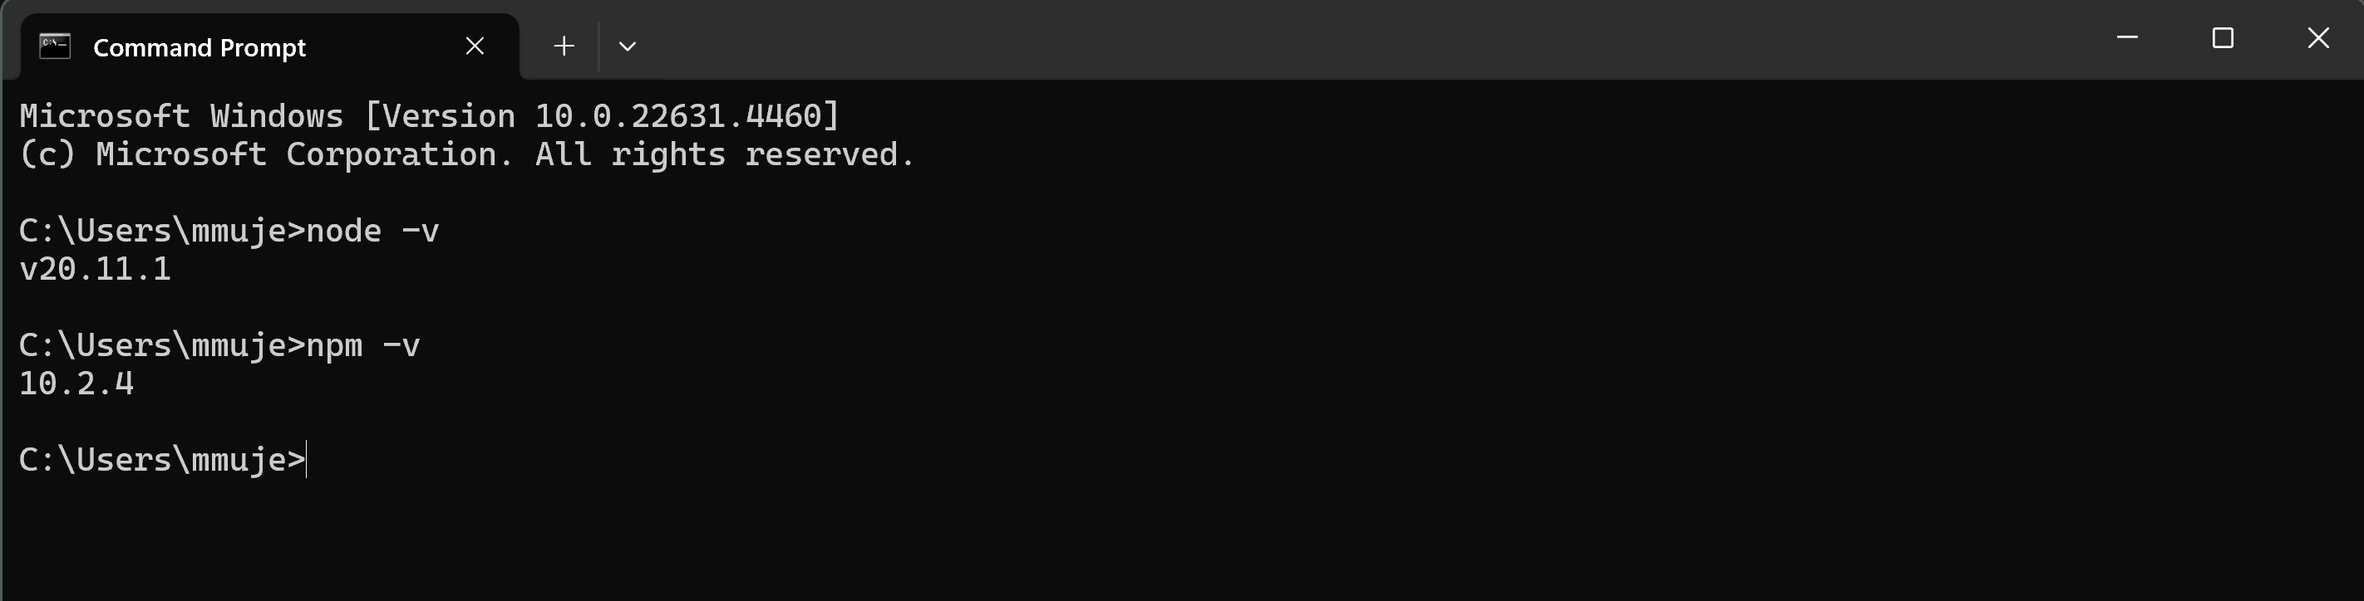

* Step 10: If node.js was completely installed on your system, the command prompt will print the version of the Node JS installed. If for some reason it gives you error regarding “node not recognized” either your installation was not successful, or if the installation was successful you only need to add the path to your node.js installation in the environment variables.
  + Search in start menu “environment variables”

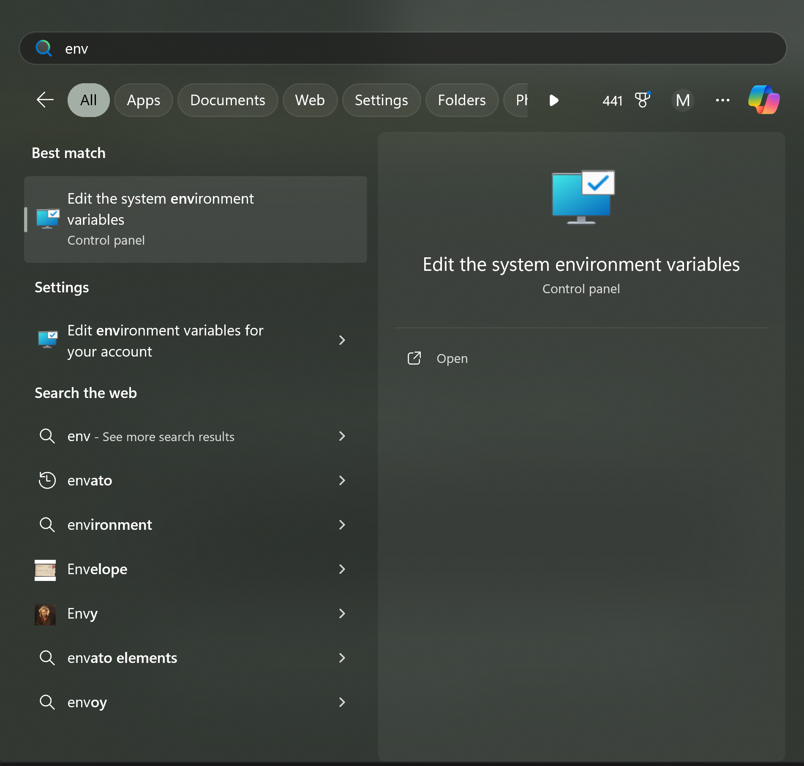

* + Click on “Environment Variables”

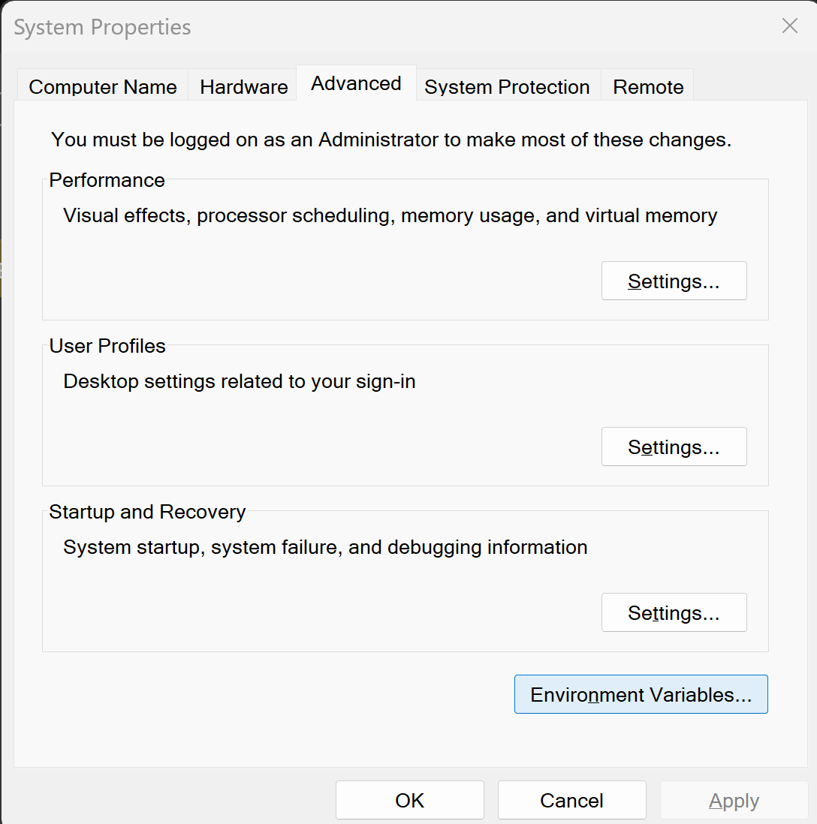

* + Select “Path” and click on “Edit”

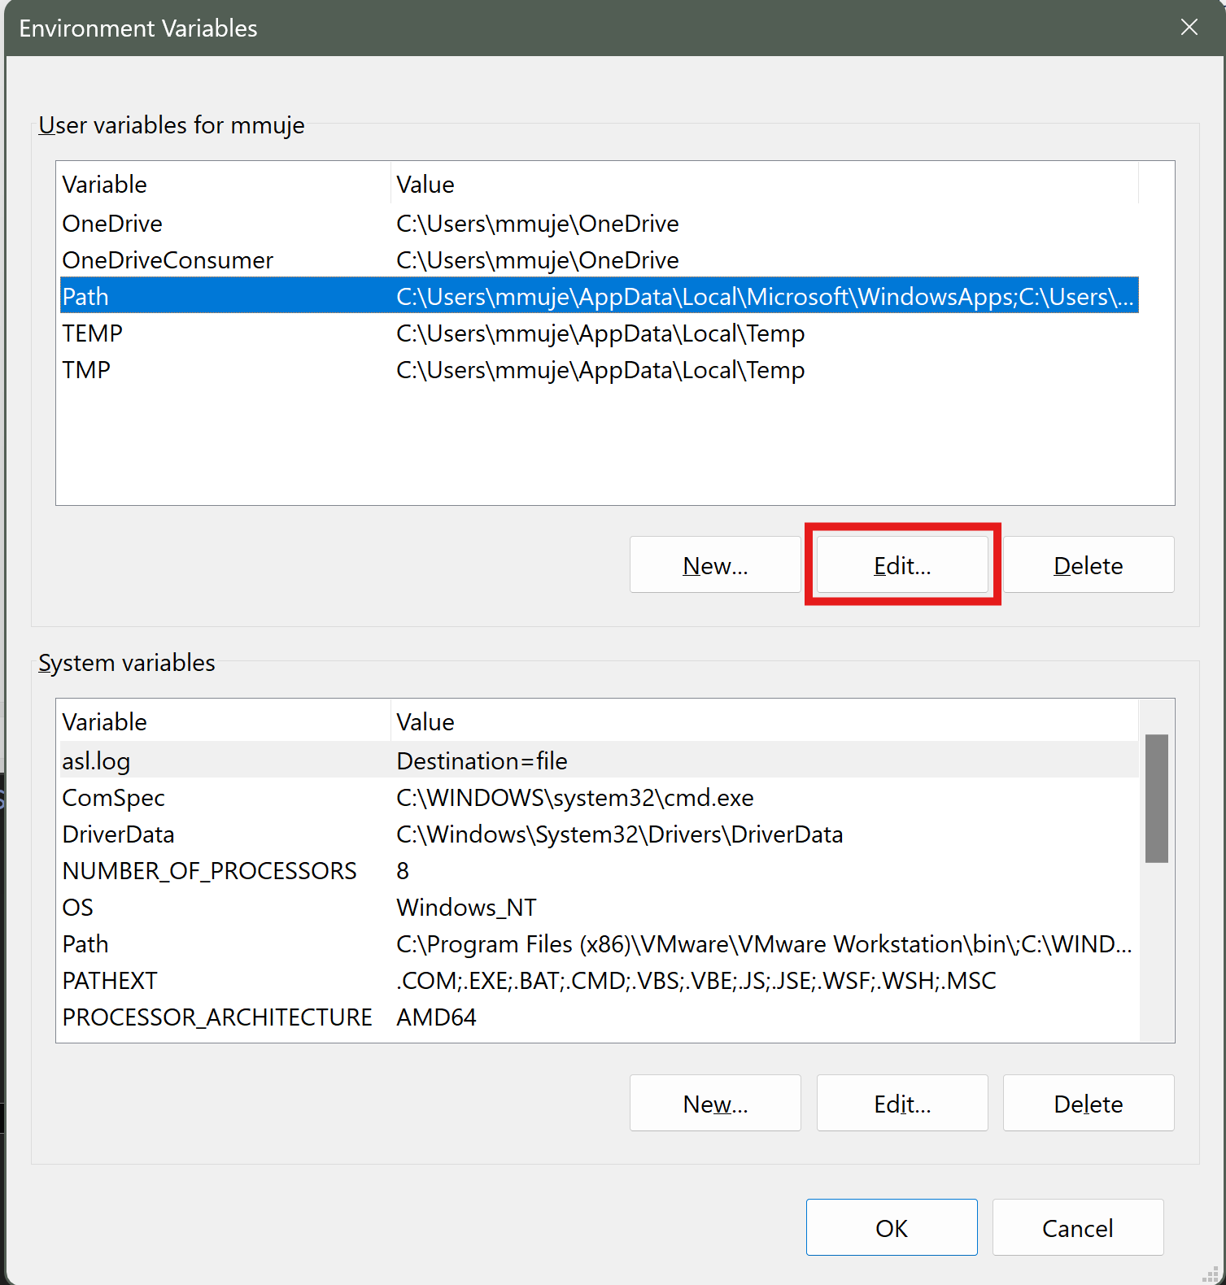

* + Click on “New” and then click on “Browse” to select the destination of where you installed your node.js.

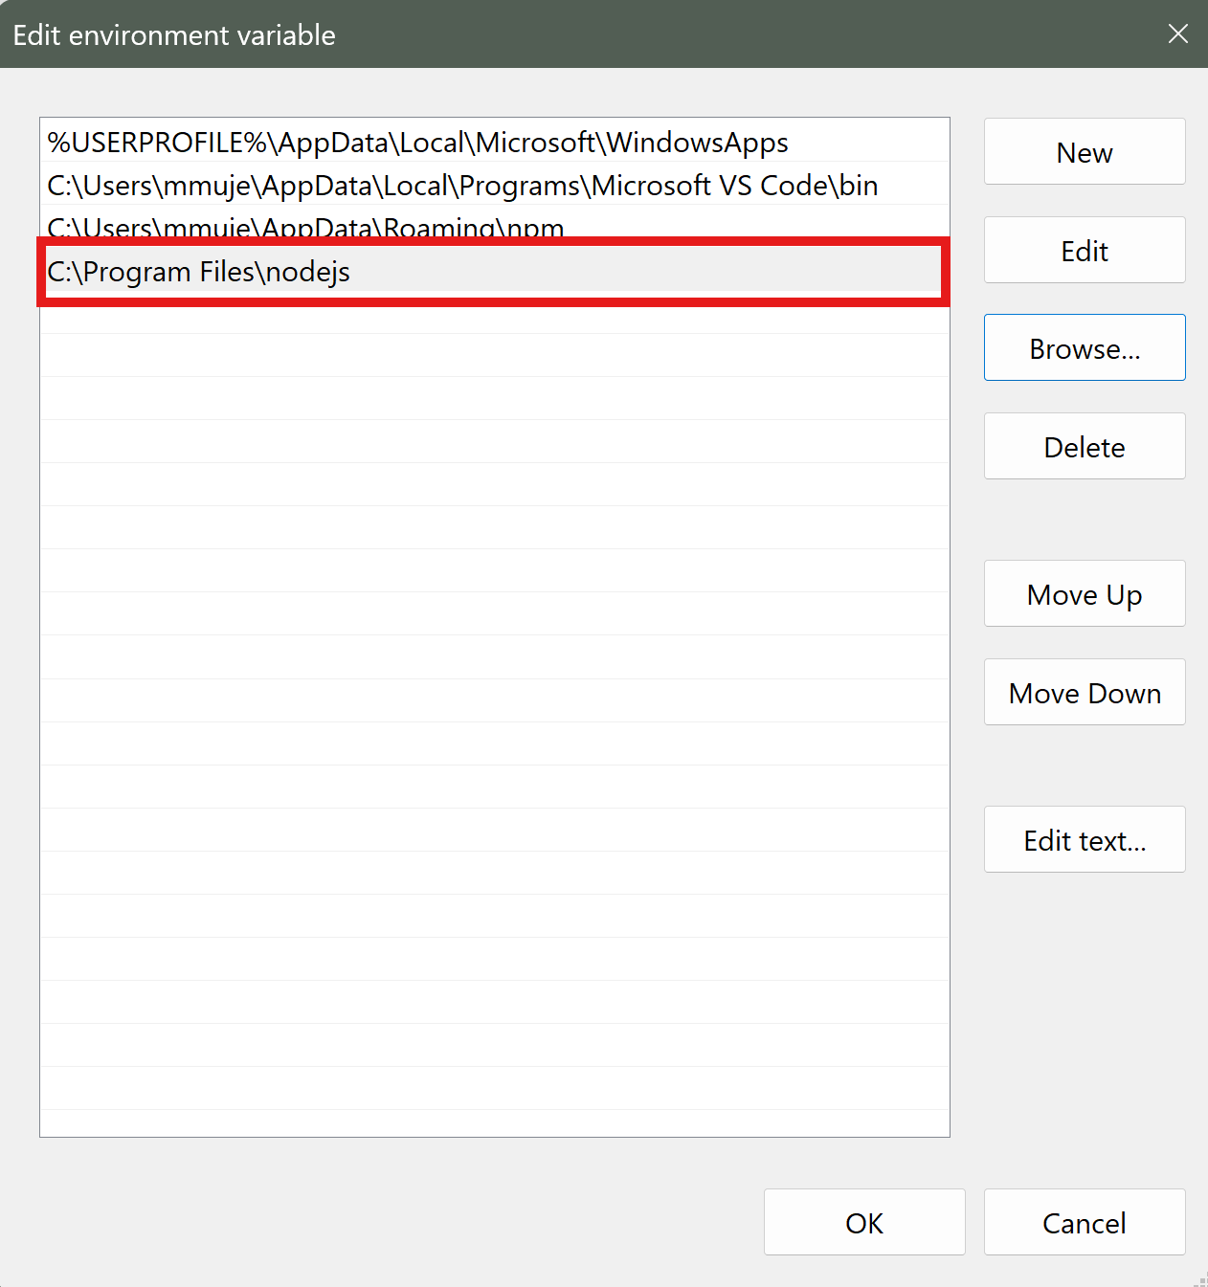

* + Click “OK” and close all the modals, this will save your settings. Now you can retry the Step 9 in node.js installation.

With this the installation of node.js is completed.

### Installation on Linux

Note: Keep in mind that installation might defer based on the linux distro on deployment environment. Additionally, before any package installation, do remember to update your system packages. If you are doing the installation at once, you only need to do it once.

#### 

#### Installation of web server

* Nginx web server: Installing Nginx on linux machine, follow the steps below.
* Step 1: First step is to update your system packages.

```````

Ubuntu/Debian: sudo apt update

Centos/RHEL: sudo dnf upgrade

**```````**

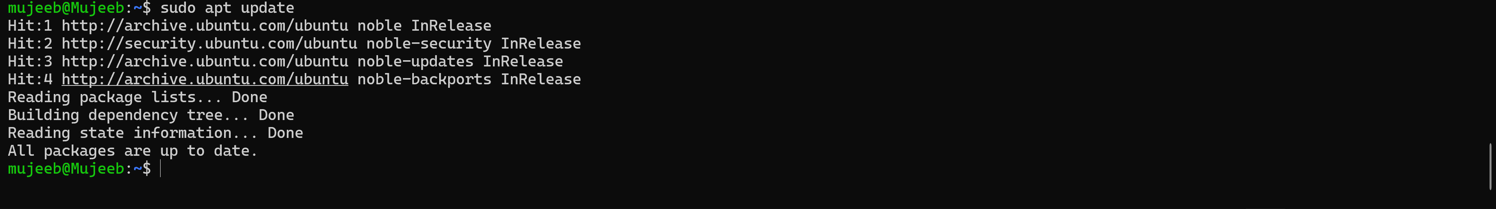

* Step 2: Install nginx web server

````````

Ubuntu/Debian: sudo apt install nginx

Centos/RHEL: sudo dnf install nginx

````````

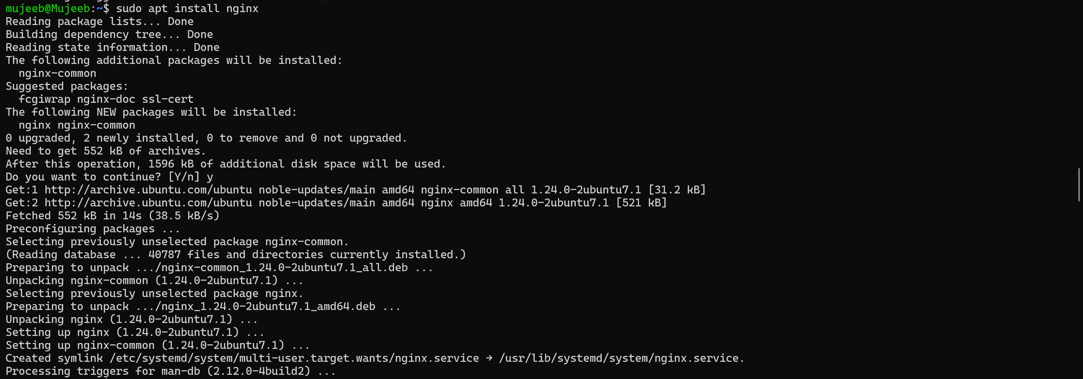

* Step 3: Enable and Start the nginx web server. Along with it we can check the status after the two command of our web server

````````

Ubuntu/Debian: sudo systemctl enable nginx

Centos/RHEL: systemctl enable nginx or service nginx enable

Ubuntu/Debian: sudo systemctl start nginx

Centos/RHEL: systemctl start nginx or service start enable

Ubuntu/Debian: sudo systemctl status nginx

Centos/RHEL: systemctl status nginx or service status enable

````````

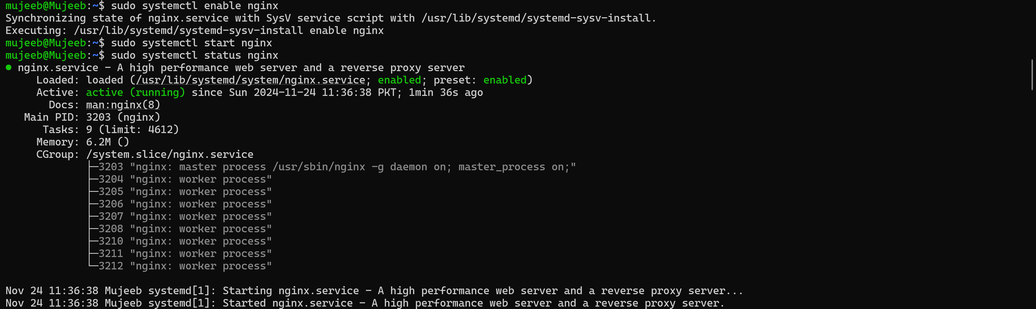

* Step 4: You can verify by either accessing port 80 of the machine using it’s IP in a web browser. Additionally you can use the “curl” command to check if it returns a web page.

```````

curl <http://your-machine-ip:80/>

```````

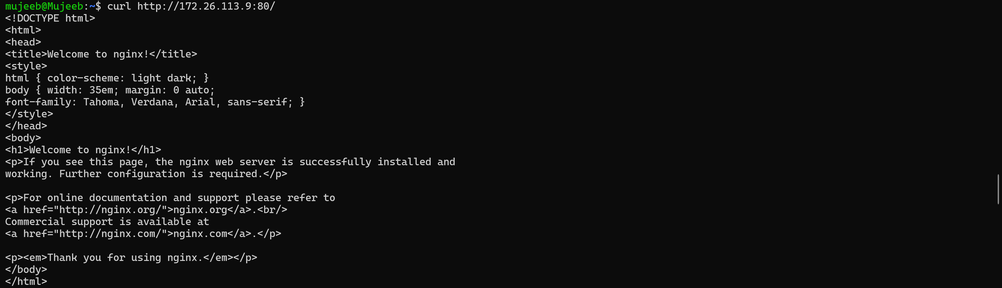

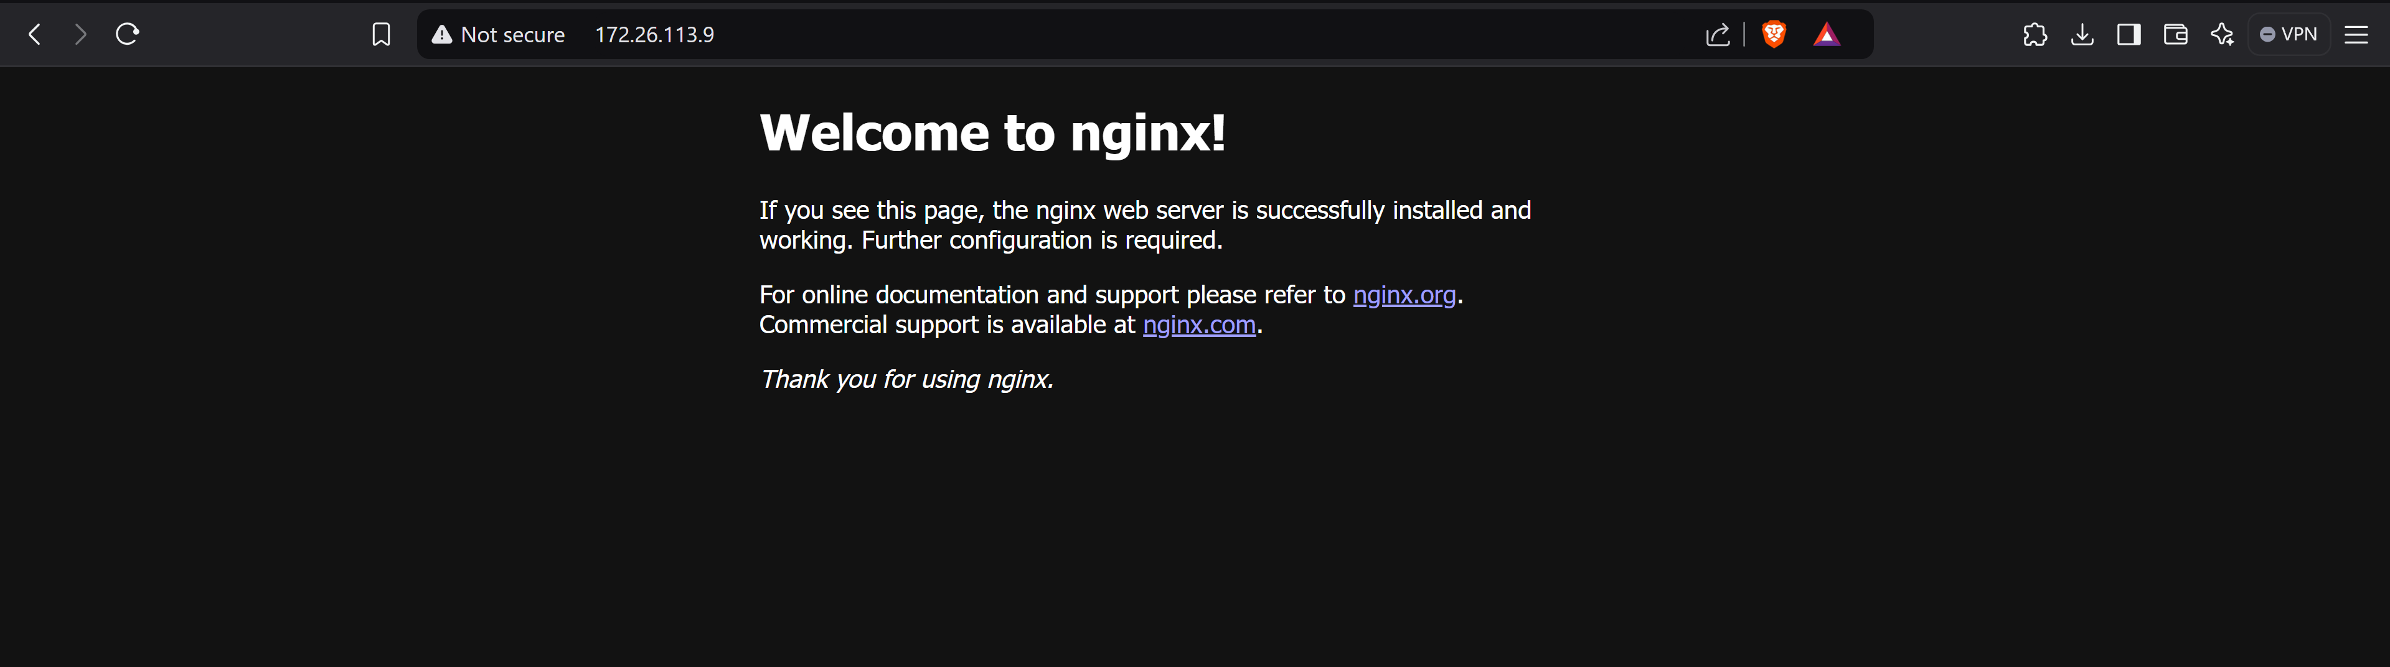

#### Installation of MySQL and creating empty database

* Step 1: Installing mysql server on linux machine

````````

Ubuntu/Debian: sudo apt install mysql-server

Centos/RHEL: sudo dnf install mysql-server

`````````

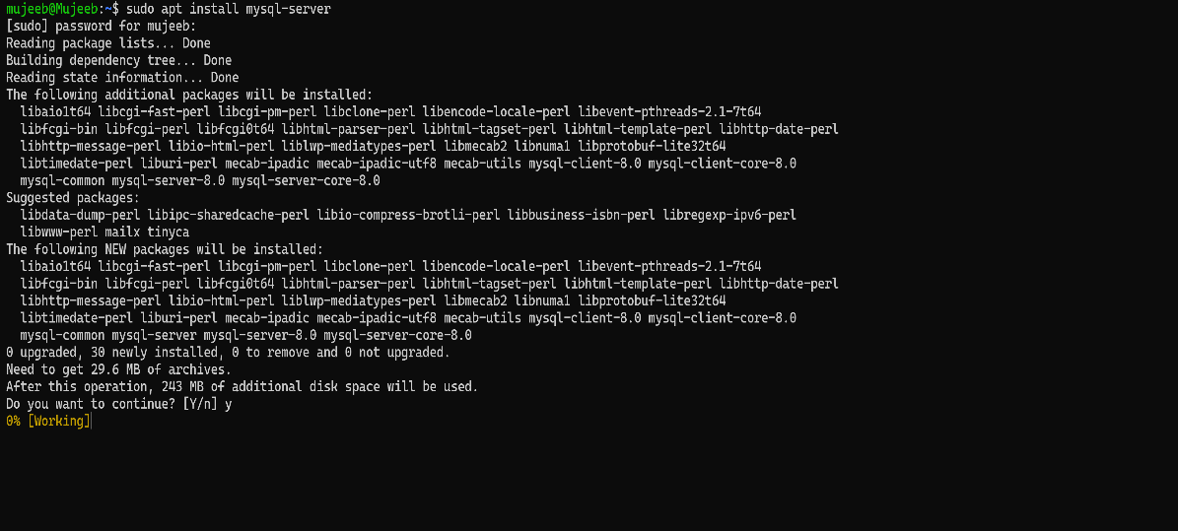

* Step 2: After installation, you can start the MySQL service using either of the two commands

`````````

systemctl start mysql

Or

service mysql start

`````````

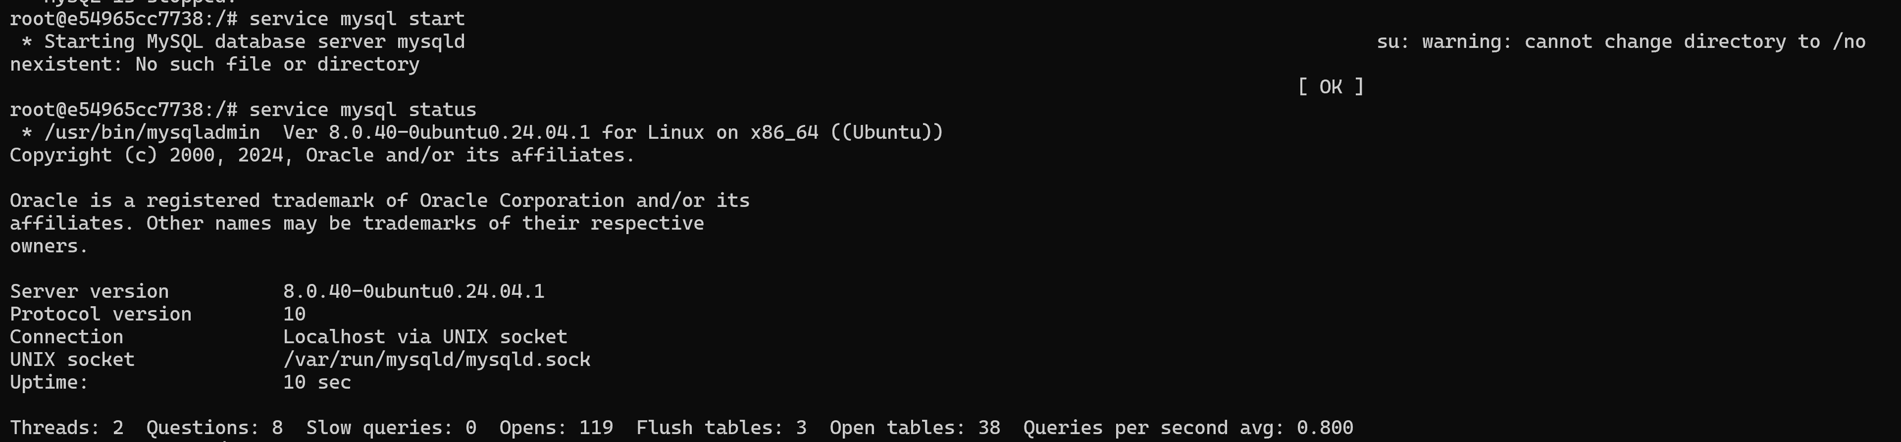

* Step 3: The status of the MySQL can be checked using the command

````````

systemctl status mysql

or

service mysql status

`````````

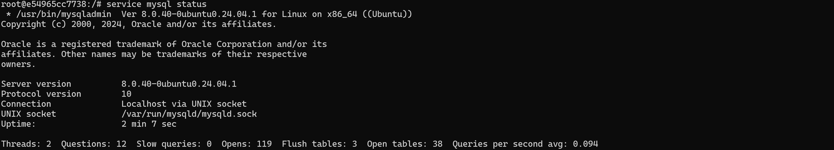

* Step 4: Next, we need to log in to MySQL and create a user and initialize an empty database for our application

`````````

mysql -u root -p

-- Database for application

CREATE DATABASE your_database_name;

*-- For remote access*

CREATE USER 'your_app_user'@'%' IDENTIFIED WITH mysql_native_password BY 'your_password';

*-- For remote access*

GRANT ALL PRIVILEGES ON your_database_name.* TO 'your_app_user'@'%';

*-- Apply privileges*

FLUSH PRIVILEGES;

*-- Verify*

SHOW DATABASES;

SELECT user,host FROM mysql.user;

```````````

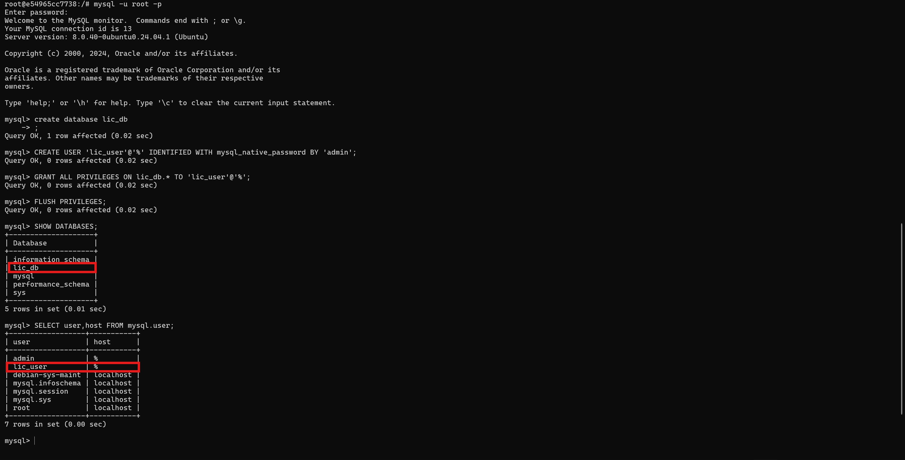

* Step 5: Configure Remote Access to allow the remote connection

```````

*# Edit MySQL configuration*

sudo nano /etc/mysql/mysql.conf.d/mysqld.cnf

*# Find and change bind-address line to:*

bind-address = 0.0.0.0

*# Or comment it out with*

*# for all interfaces*

*# Save and restart MySQL*

sudo systemctl restart mysql OR service mysql restart

````````

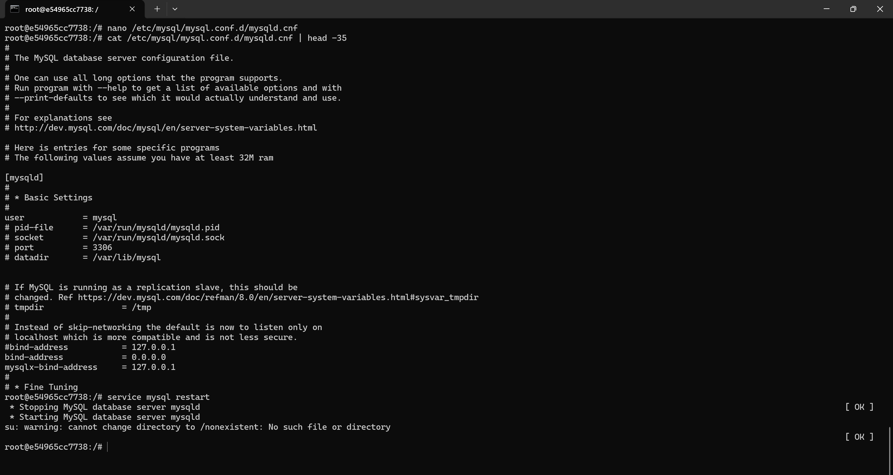

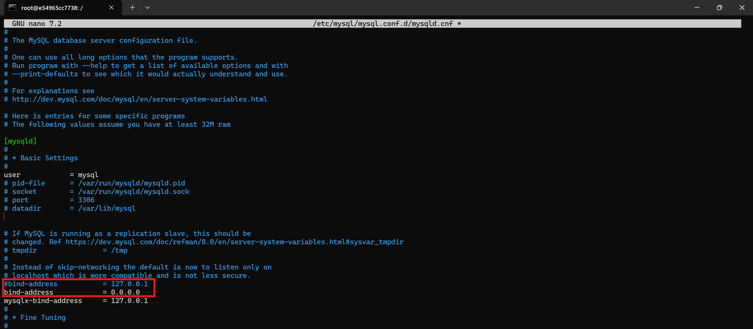

Screenshot of file /etc/mysql/mysql.conf.d/mysqld.cnf

With this the installation of MySQL with its tools are installed and configured. Additionally, we have also initialized a database which we will need later.

#### Installation of node.js

* Step 1: Updating system packages

````````

Ubuntu/Debian:

sudo apt install curl -y

RHEL/CentOS:

dnf install curl -y

`````````

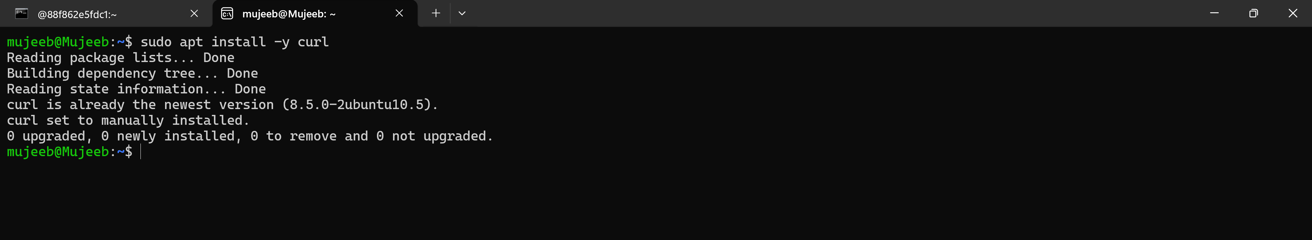

* Step 2: Add NodeSource repository for Node.js 20:

```````

Ubuntu/Debian

curl -fsSL https://deb.nodesource.com/setup_20.x | sudo -E bash –

RHEL/CentOS

curl -fsSL https://rpm.nodesource.com/setup_20.x | sudo -E bash –

```````

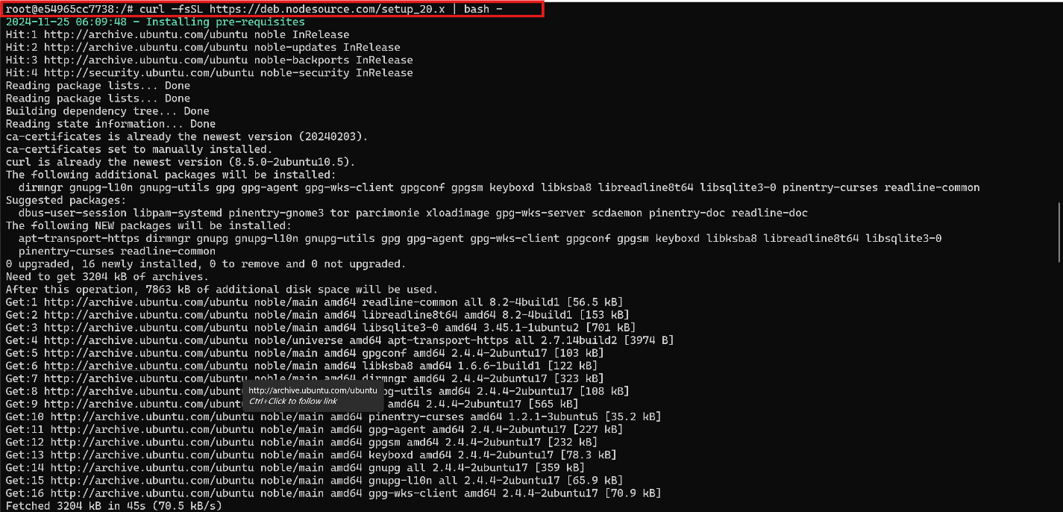

* Step 3: Install Node.js:

```````

Ubuntu/Debian: sudo apt install -y nodejs

RHEL/CentOS: sudo dnf install -y nodejs

```````

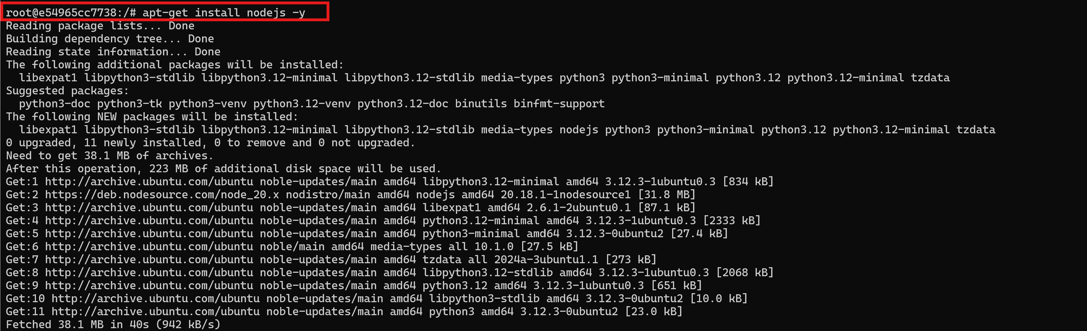

Note: While downloading, it is possible that it prompts to select time zone as shown below

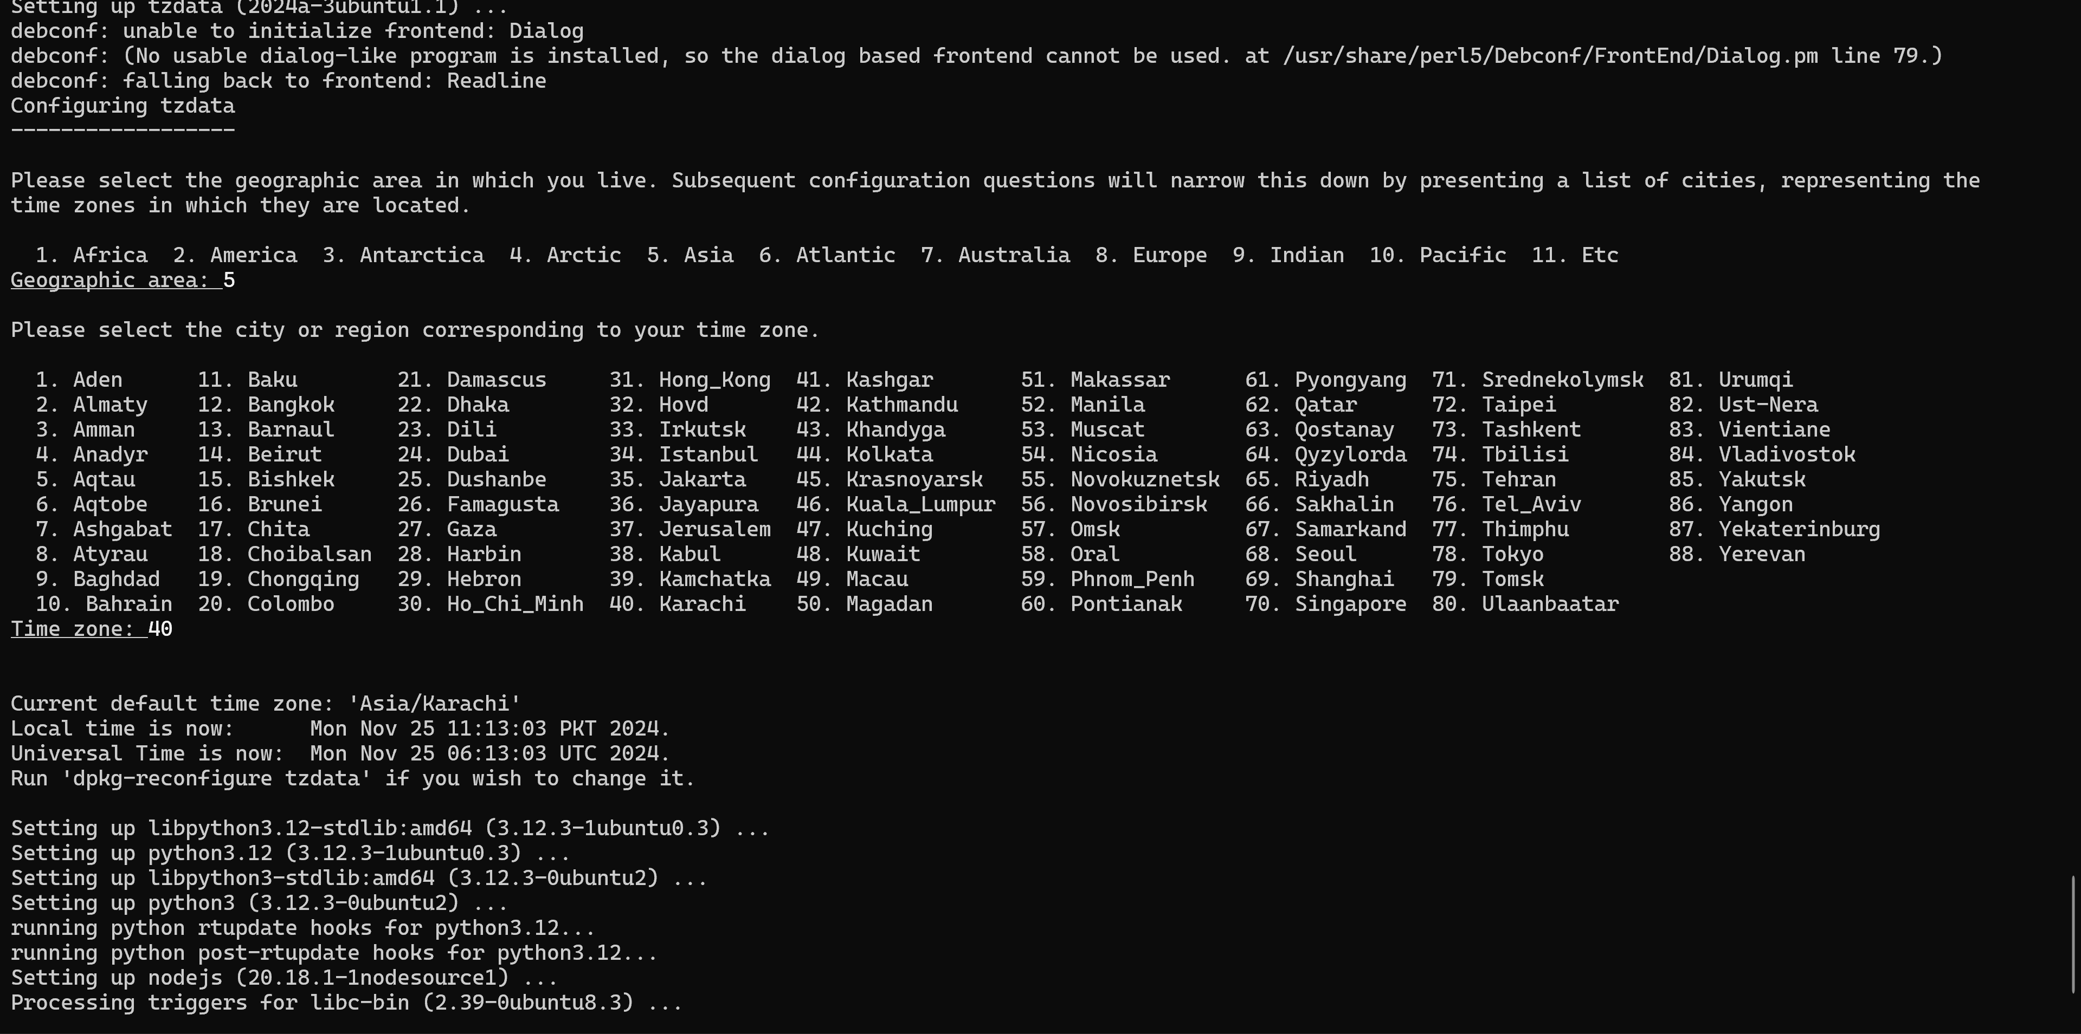

* Step 4: Verify installation:

````````

node --version

npm --version

````````

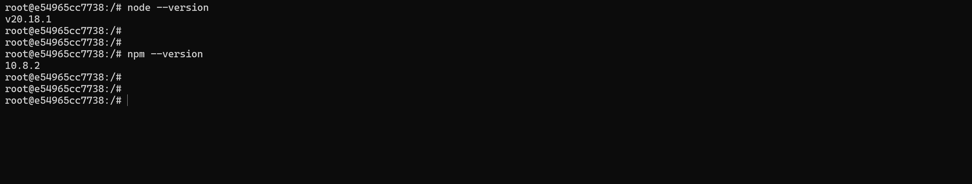

With this the installation of node.js is completed.

## Download codebase

* Now that the dependencies based on your platform are installed, we can move to the application setup. The application will be provided through either a link from where you can install it or through any other medium the client prefers. The basic directory structure you will see is this. You will see only two folders as follows.



Now that all the tools and application is installed. Let us move towards the initial configuration of the application.

## Backend Setup

* + First let’s setup the backend. Navigate to your “licenseManagerBackend” directory. The first thing to do is edit the .env file.

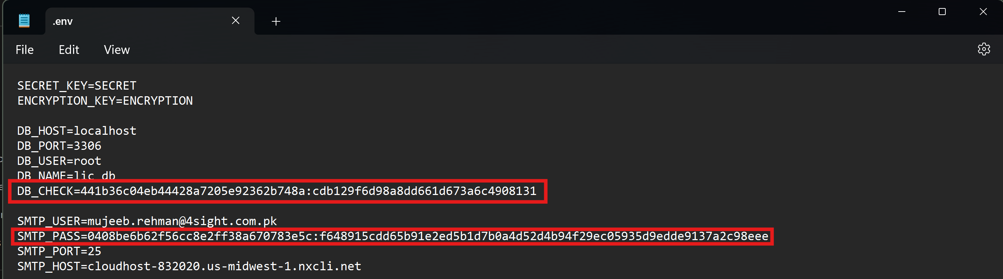

The .env file contains the database configuration and the SMTP configuration. You will need to change the values based on your configuration.

*Important Note:* Keeping in mind security, you can see that the database password and the SMTP password are both encrypted. Once you enter your password and start the application. The passwords will be encrypted automatically.

* + Second, we need to install all the dependencies of the application. For this reason, open CMD and navigate to the backend directory and run the following command.

`````````

npm install

`````````

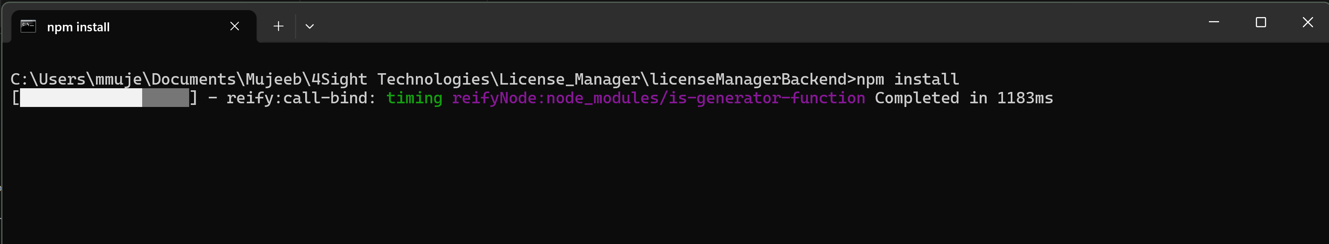

After the installation is complete you should see a message similar to this indicating successful installation of dependencies.

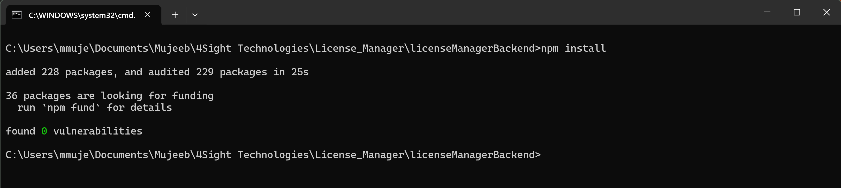

* + *Important Note:* before proceeding, a license for your application to run is needed to be generated. This step can only be done by the Application Provider.
  + Third, after the license generation, now you need to open CMD and navigate to the “licenseManagerBackend” directory and run the following command.

````````

npm install -g pm2

````````

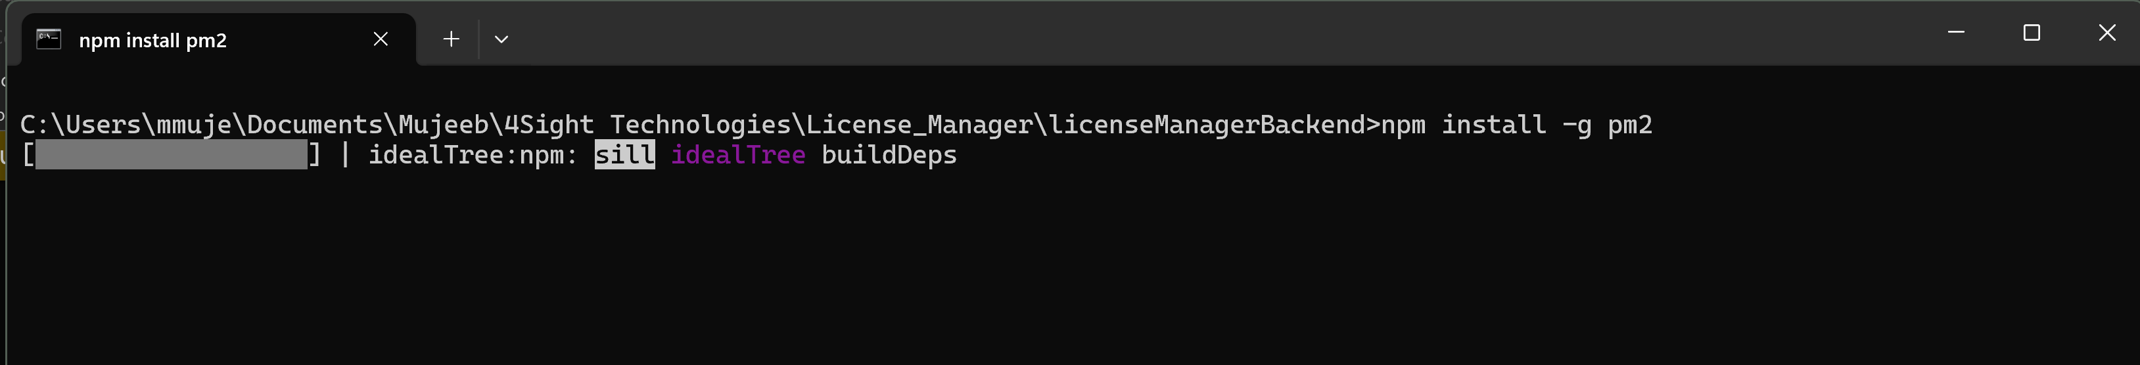

If your do not see such interface, and get an error please check your node installation. After installation you will get this message.

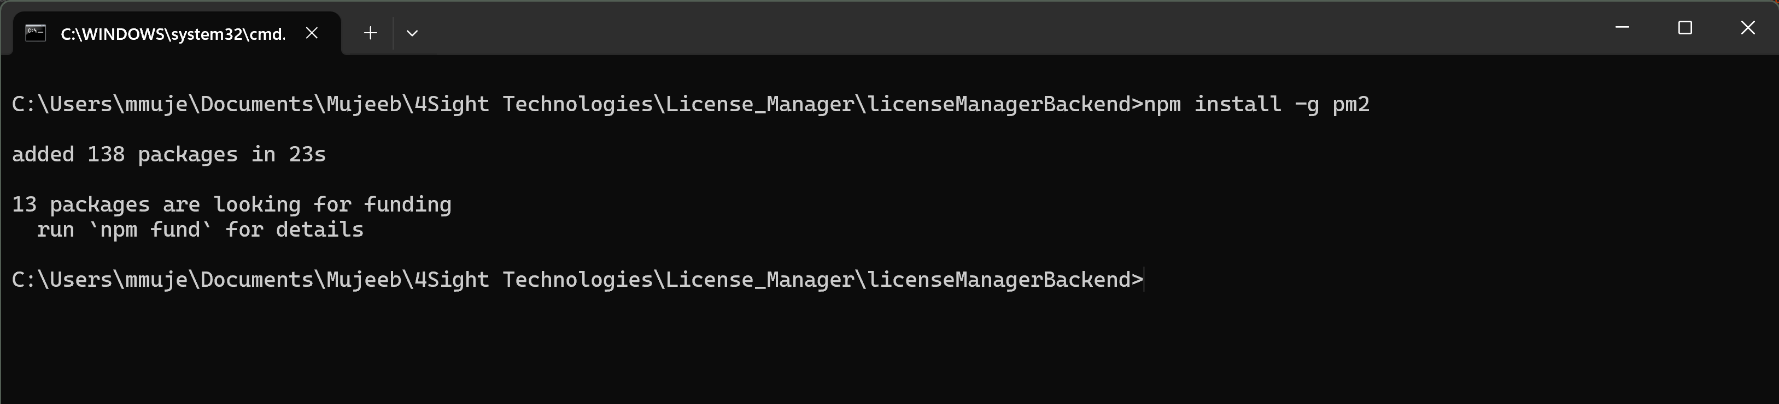

* + Fourth, now our backend is ready to be started using pm2, this is used to ensure the application starts automatically on a reboot. Additionally, pm2 helps in load balancing as well. Run the following commands in CMD staying in the same directory.

````````````

pm2 list

````````````

This command shows us the list of applications that pm2 is handling. Initially it should be empty.

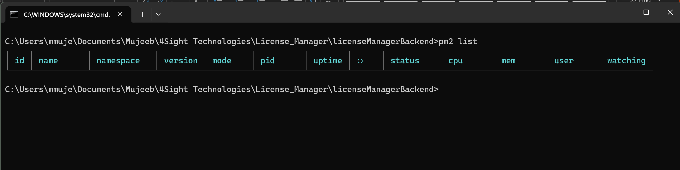

`````````

pm2 start app.js --name LicenseManagerBackend

`````````

This command starts the application using pm2 service manager. After this you can run the following command to save our state or list of services. This will help us when rebooting the machine.

````````

pm2 save

````````

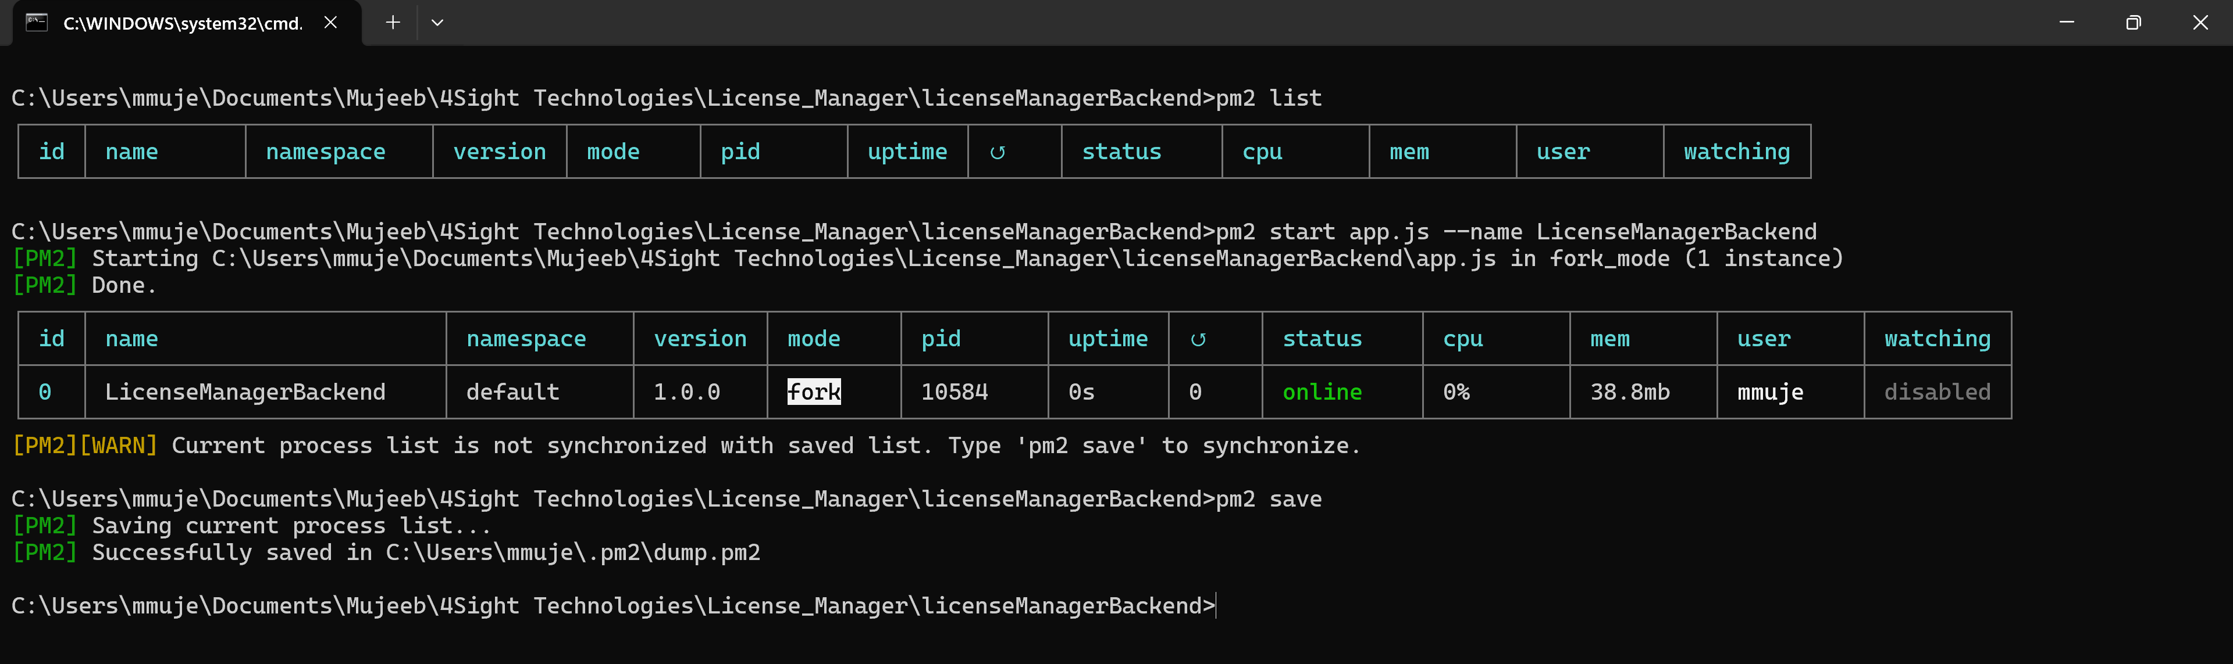

* + To make sure that your application has started and it has connected to the database. We can run the following command.

````````

pm2 log LicenseManagerBackend

````````

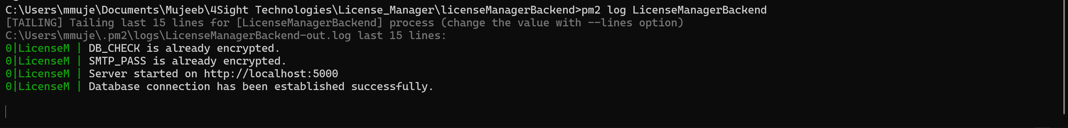

If you see error logs, it is highly likely that there is issue in database configuration. More information can be inferred from the error logs.

* + Now our backend is setup and running. Here we have a difference of setup in linux and windows to ensure our application starts when the machine **reboots**. Follow the below step based on your Platform.

**Steps for windows:**

* + Step 1: In **CMD,** run the following command to install a package for our application

````````

npm install -g pm2-windows-startup

````````

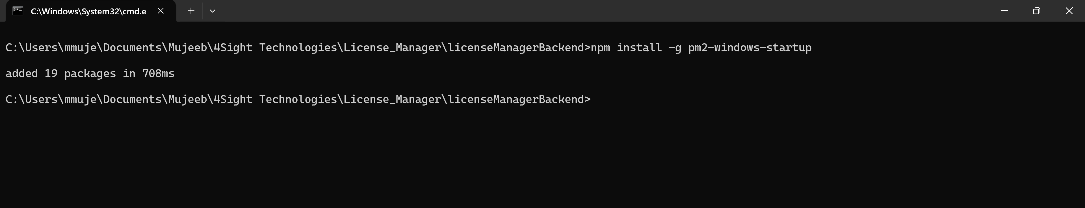

* + Step 2: Now run the below command to ensure that your application is started if the machine reboots.

````````

pm2-startup install

````````

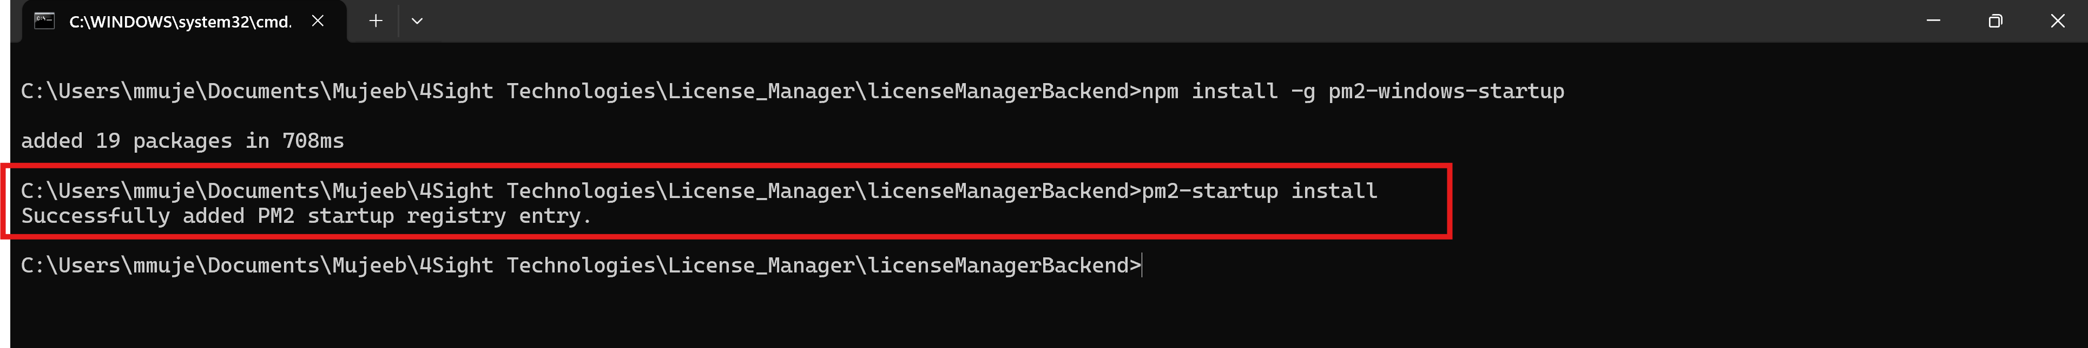

* + Step 3: Lastly, run the following command to save our service managers state.

````````

pm2 save

````````

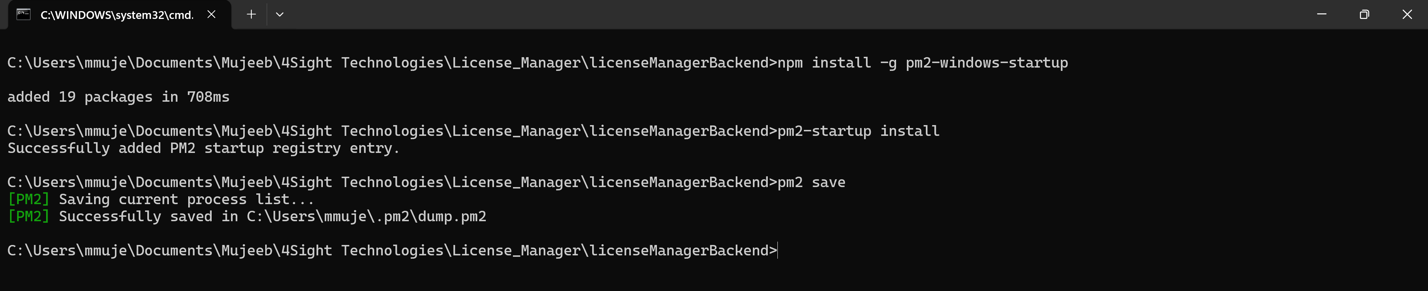

**Steps for Linux:**

* Step 1: On linux it is simpler to achieve this, we do not need to install any other package. After you had checked the log for the application, you need to run the following command.

**````````**

pm2 startup

````````

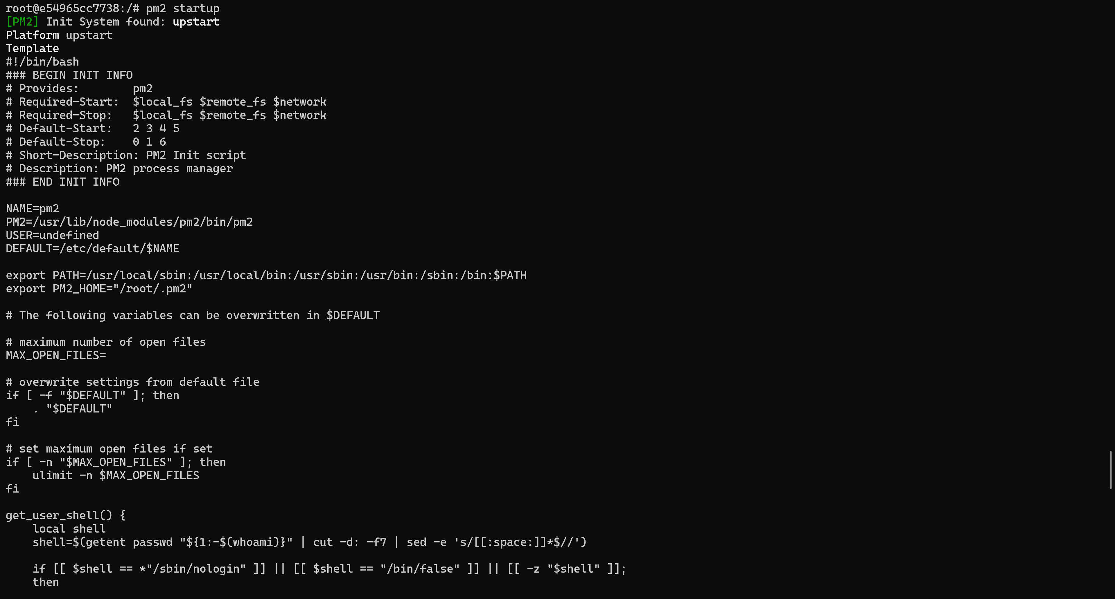

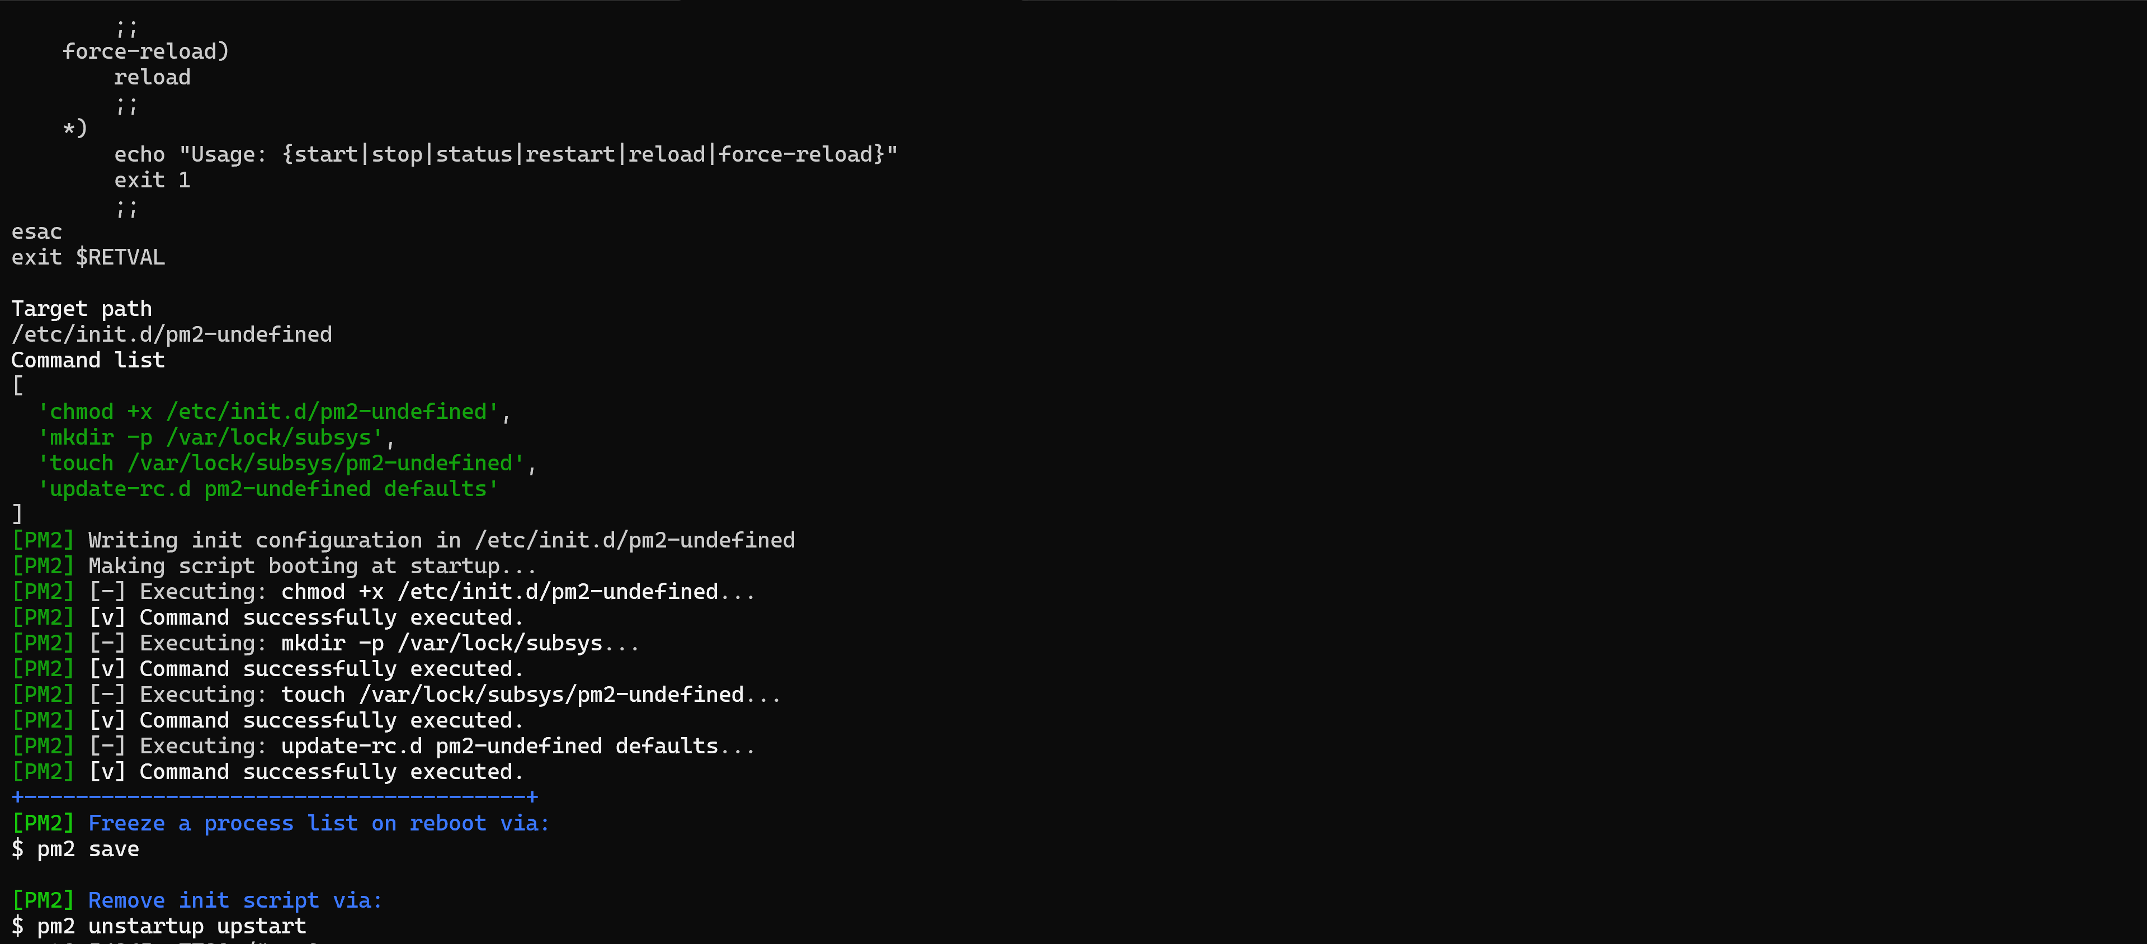

And that is the only step. This will ensure that the application starts automatically if the machine reboots. Do keep in mind to run **“pm2 save”** at the end to ensure that all settings are saved.

## Frontend Setup

* Step 1: now we need to setup the frontend. Navigate to the “licenseManager” directory and open the .env file. Add your backend application url here.

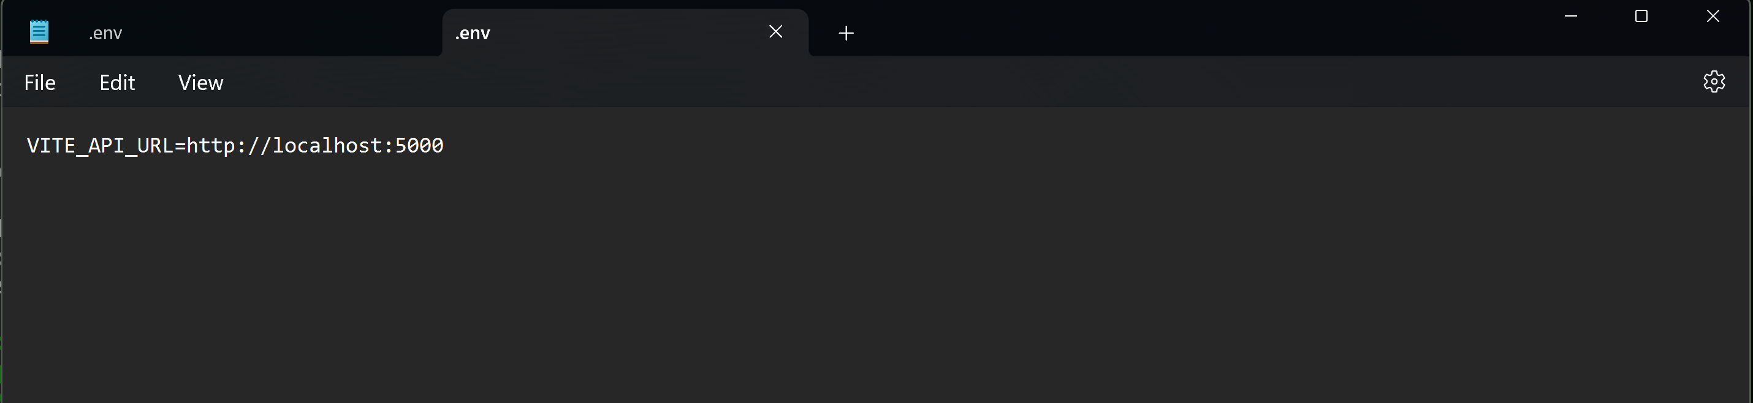

* Step 2: open “CMD” and navigate to the “licenseManager” directory and download all the dependencies.

```````

npm install

```````

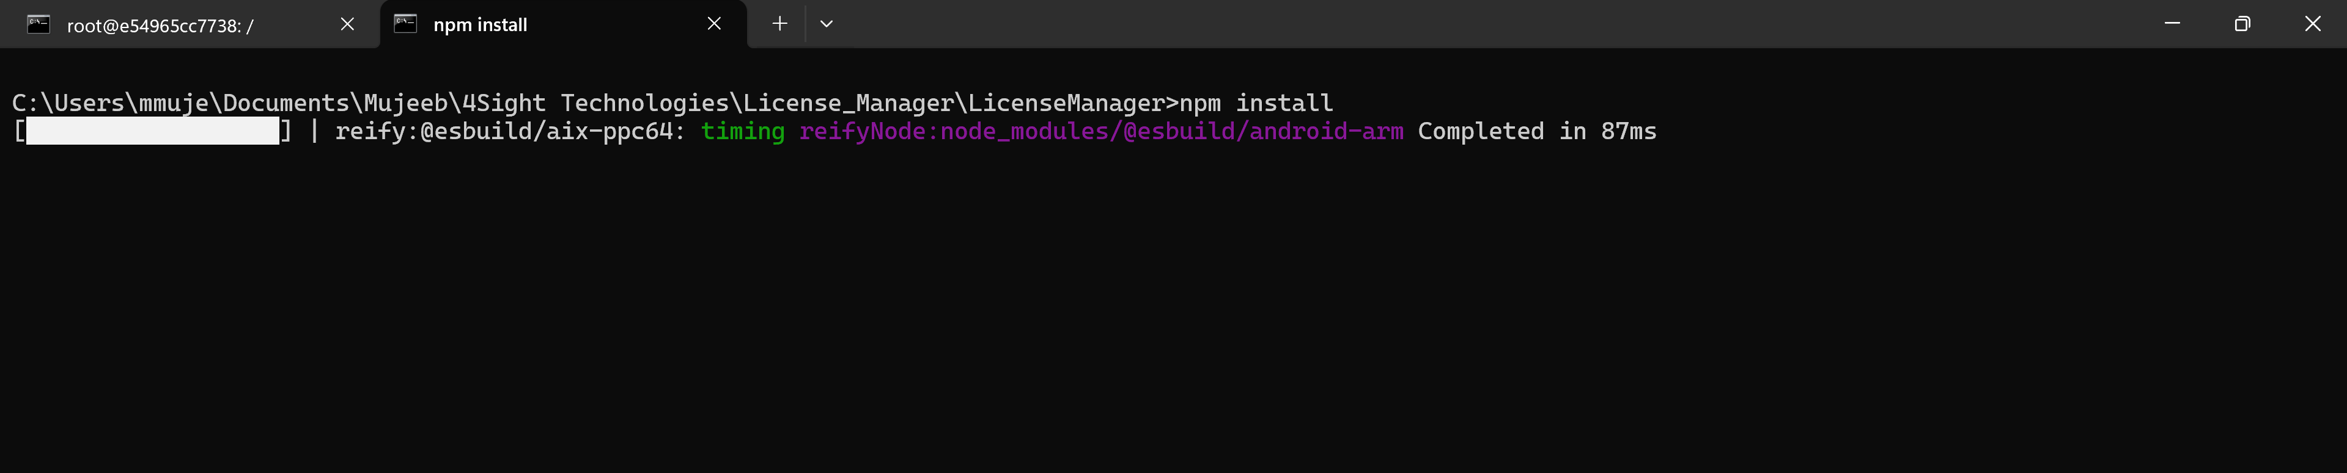

* Step 3: Now we need to build our application which then will be hosted on the web server we had installed in the previous steps.

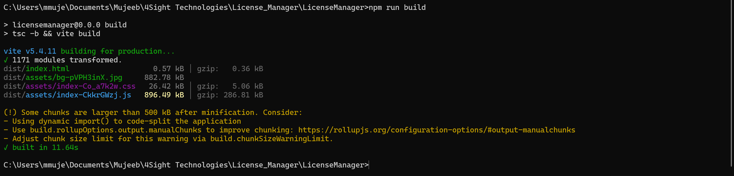

Note: After build is completed, you can verify by checking if you have a “dist” folder.

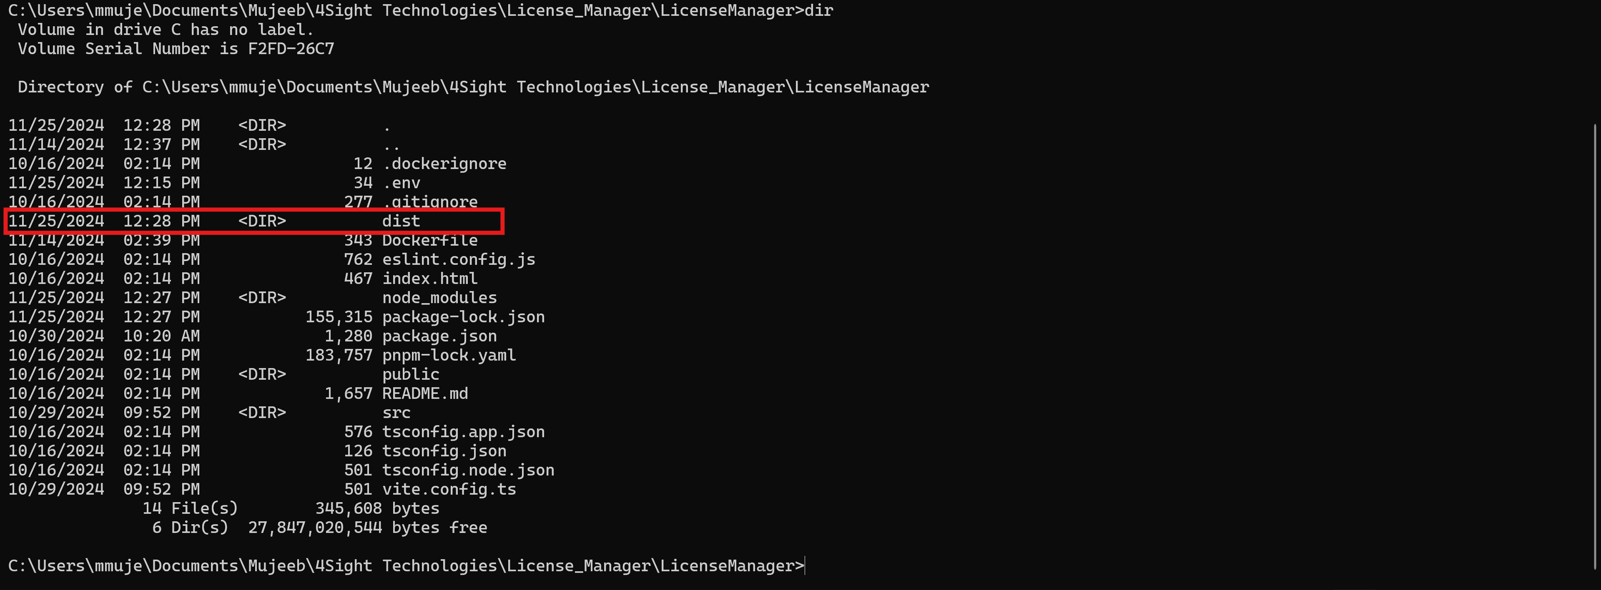

* Step 4: From this point, the deployment for Linux and Windows is different. In the below steps, the guide shows how to deploy the site on IIS in windows and on nginx for linux.

Steps for windows:

* + Step 1: To ensure that there are no permission conflicts, I placed my application files in the default directory of IIS.

````````

Default directory: C:\inetpub

````````

Create a new folder for your application and copy the contents from the “dist” directory into the new directory you created.

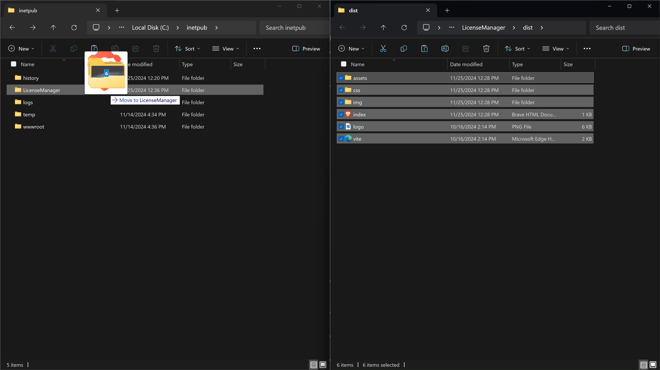

* + Step 2: Open your IIS and go to sites section and click on Add Website to host our frontend application.

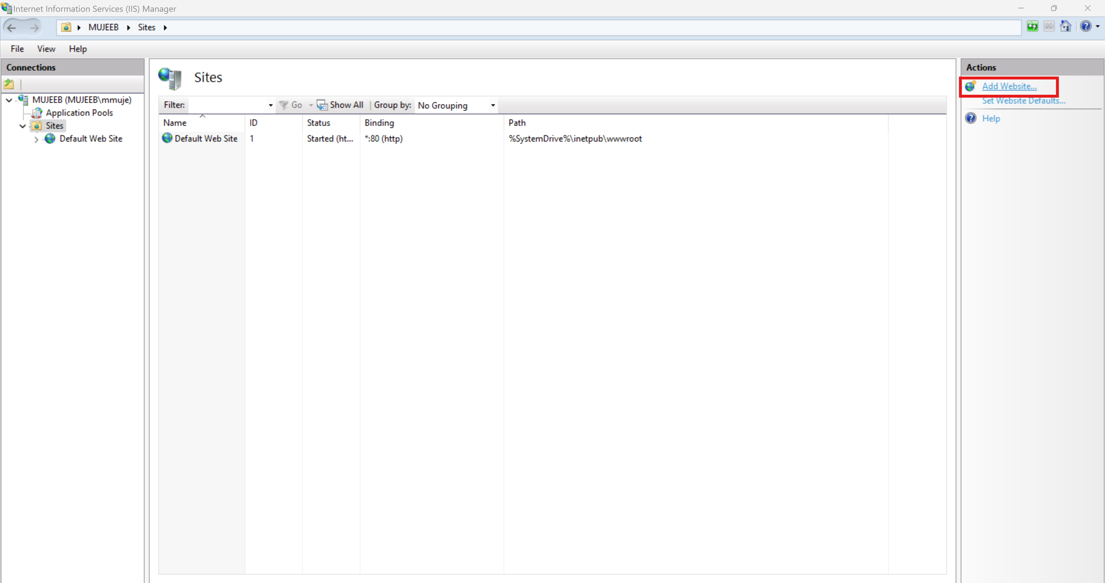

* + Step 3: Adding our website to IIS

1. Add a name for your website and leave the Application pool to what it is.
2. Select the path where the files are placed. As per our step 1, we have placed them into C:\inetpub\LicenseManager.
3. Lastly, you can change the port, I myself have changed the port to 81.
4. Click “OK”

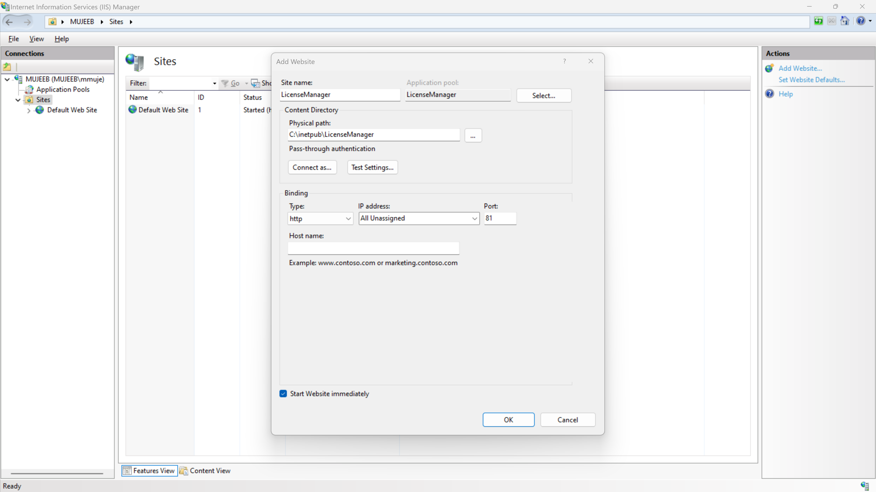

* + Step 4: Last step is to verify our deployment. Now we can access our application through the web browser.

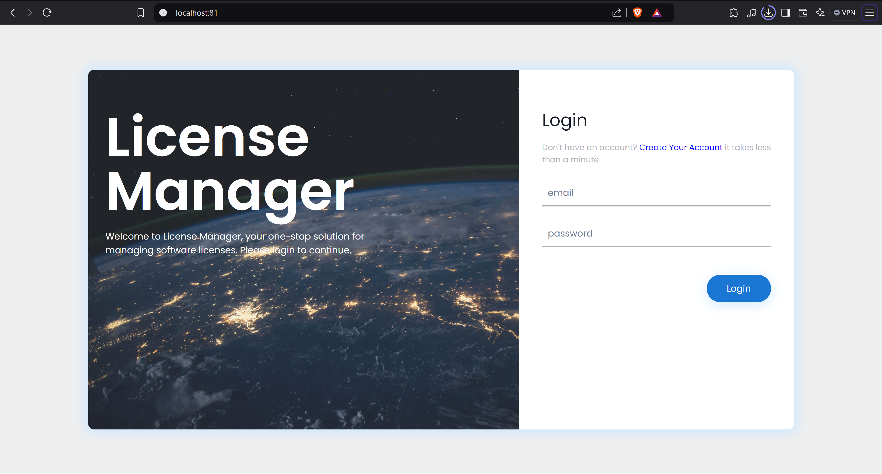

Steps for Linux:

* + Step 1: Verify that you have nginx installed and you have the application on the machine. If anything is missing, please follow the steps in the previous sections.

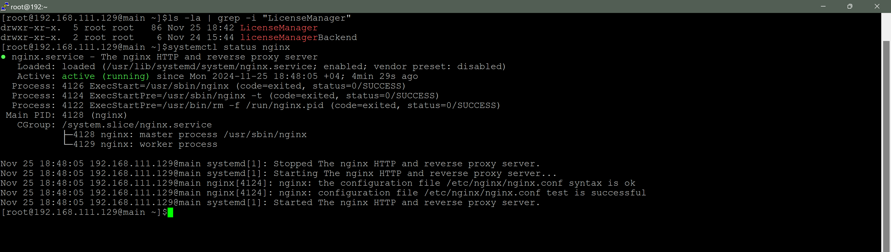

* + Step 2: In the LicenseManager directory I placed the contents of the “dist” folder.

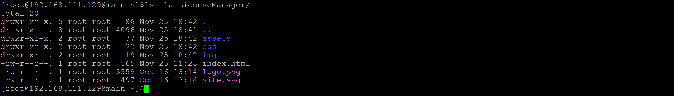

* + Step 3: Next, navigate to the directory “/usr/share/nginx/html/”

```````

cd /usr/share/nginx/html/

rm -rf *

```````

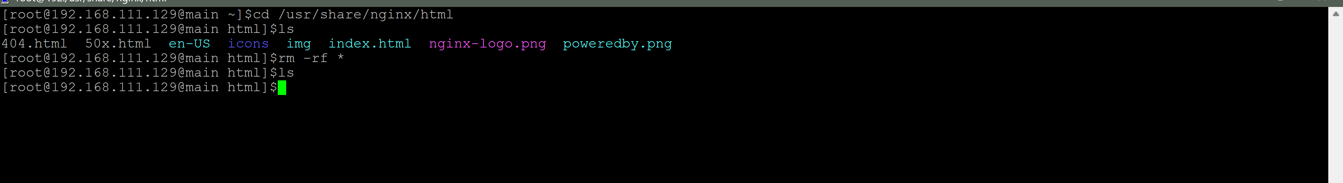

* + Step 4: Now we need to copy the files from our “LicenseManager” directory to this “html” directory.

``````````

cp -r path-to-LicenseManager/* /usr/share/nginx/html/

systemctl restart nginx

``````````



* + Step 5: Now we can access our application in a web browser

